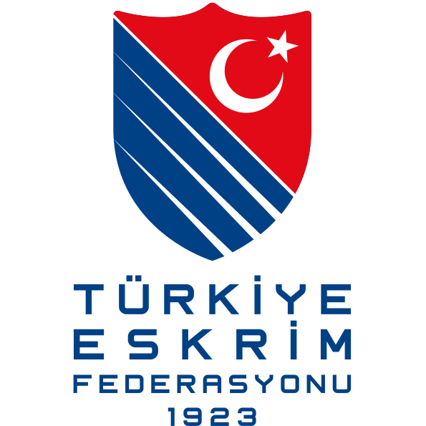

ANTALYA SATELLITE TOURNAMENT

FIE Satellite Man’s and Woman Foil
10-11 December 2016

Dear Friends,

On behalf of Turkish Fencing Federation, I would like to invite you to Antalya Satellite Tournament, in Antalya 10-11 December 2016.

Details of the competition as follows:

Organiser:
Turkish Fencing Federation
İstanbul Yolu, Gersan, 2307 Sok. No: 65 Ankara / TÜRKİYE
Tel: +90 (312) 255 11 61 / +90 (312) 255 12 61
Faks: +90 (312) 255 71 61
tef@eskrim.org.tr

Competition venue
Antalya Arena Sports Hall, Meltem Mah., 2. Cd. 6 P, 07030 Sakıp Sabancı Bulvarı, Muratpaşa/Antalya

Schedule of the Competition
FRİDAY
09 Dec 2016 : 16:00 – 19:00 Registration / Weapon Control
SATURDAY
10 Dec 2016 : 08:30 – 09:30 Registration /Weapon Control
: 10:00 Last Entry
: 10:30 Starting to pools of Men Foil
: 17:00 Semifinals – Final
SUNDAY
11 Dec 2016 : 08:30 – 09:30 Registration /Weapon Control
: 10:00 Last Entry
: 10:30 Starting to pools of Woman Foil
: 17:00 Semi-finals – Final

Equipment
All equipment must be within the FIE standards.

Entry
Open to all fencers with valid 2016-2017 FIE License.
No fencer is allowed to take part in an official event of the FIE unless he or she is at least 13 years old on 1 January in the year of the competition.
Entries of fencers, teams and referees can only be made at the FIE website, www.fie.org, respecting the deadlines specified in the FIE Rules (cf. o.54).

Entry fee
Individual competition: EUR 40.
The entry fee can also be paid at registration before the start of the competition.

Referee Obligation
Each country is required to send referees according to the FIE rules.

Formula
The Satellite competitions shall use the F.I.E. formula for junior competitions (cf. o.35-o.41).

Accommodation and Transport
http://downtownantalya.rixos.com/
http://www.ozkaymakfalezhotel.online/
http://www.gridacity.com/
http://sunishotels.com/TR/Hotel-SU/

You can make your order for accommodation and transportation to our official e-mail address written below; E-mail: organization@eskrim.org.tr Phone: +90 507 2819302

Visa Support
Kindly check for visa requirements to Turkey before making your ticket reservations. Those who need visa assistance and/or visa support, please contact organization@eskrim.org.tr no later than 18.11.2016.

Further information and contact person
Turkish Fencing Federation, Abdussamet ARSLAN +90 507 2819302, organization@eskrim.org.tr

Warm regards,

Murat ATALI
President

