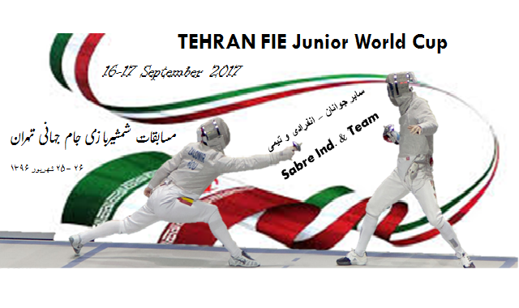
Tehran FIE World Cup

FIE Junior World Cup
“Men’s Sabre, Individual and Team”
16-17 Sep 2017

Dear Friends,

It is with great pleasure that I invite you to Tehran FIE Junior World Cup, on behalf of the Fencing Federation of IRAN, which will be held at Tehran on 16-17 Sep 2017.

Detail of the competition as follows:

Organizers:
The Fencing Federation of IRAN
Tehran,Iran
Telephone:+98 21 440 15727-8
Email: iranfencingfed@hotmail.com

Competition venue
Afrasyabi Sport Hall
Mofateh st, Tehran, Iran

Schedule of the Competition
Friday 15 Sep 14:00 – 21:00 Registration / Weapon Control

Saturday 16 Sep 08:00 Venue open
08:30 Payment / Weapon Control open
10:00 Start of the individual competition
16:00 Semi-finals and final

Sunday 17 Sep 08:00 Venue open
08:30 Payment / Weapon Control open
10:00 Start of the team competition
16:00 Final

Participation
Each national federation may enter a maximum of 12 fencers. The organising country may enter up to 30 fencers plus the number needed to make up the pools.
Team participation is open to all countries and limited to one team per weapon per country.

Entry
Open to all fencers with valid 2017-2018 FIE License.
No fencer is allowed to take part in an official event of the FIE unless he or she is at least 13 years old on 1 January in the year of the competition.
Fencers taking part in all the official FIE Junior competitions, individual or team, must be under 20 years old at midnight on 31st December of the year preceding the year in which the competition takes place (cf o.80)
Entries of fencers, teams and referees can only be made at the FIE website, www.fie.org, respecting the deadlines specified in the FIE Rules (cf. o.54).

Entry fee
Individual competition: EUR 25. Team competition: EUR 150
The entry fee can be paid at registration before the start of the competition.

Referee Obligation

Participating countries must be accompanied by referee with FIE A, B or P licenses as below (cf. t.35). Delegations not respecting the quota must pay a fine of EUR 1000 per referee.

1-4 fencers | No referee required
5-9 fencers | 1 referee
10 or more | 2 referees

Doping
Doping control will be done according to FIE rules.

Accommodation and Transport
Kindly contact iranfencingfed@hotmail.com no later than 25 Aug if you wish to avail of the special hotel rates provided by the Organizers.

Marlik Hotel (****) Morvarid Hotel (***)
Single: 78 EURO Single : 66 EURO
Double :100 EURO Double: 92 EURO
Triple: 125 EURO Triple:100 EURO

Visa Support
Kindly check for visa requirements to IRAN before making your ticket reservations. Those who need visa assistance and/or visa support, please contact iranfencingfed@hotmail.com no later than 25 August 2017.

Entry form
Federation:……………………………………
 | Sure Name | First Name | Father’s Name | Passport No | Date of issue | Date of Birth | Date of expiry | Position
1
2
3
4
5
6
7
8
9
10

Further information and contact person
Iran Fencing Federation, Unit 22, No 2 Paniz , North Vafaazar, Ferdous , Sadeghieh sq, Tehran ,Iran.
iranfencingfed@hotmail.com
Tel: +98 21 44015727-8
Mobile: +98 912 6952393
Fax: +98 21 440 15729

Warm regards,

Dr. Fazlollah Bagherzadeh
President of Iran Fencing Federation

