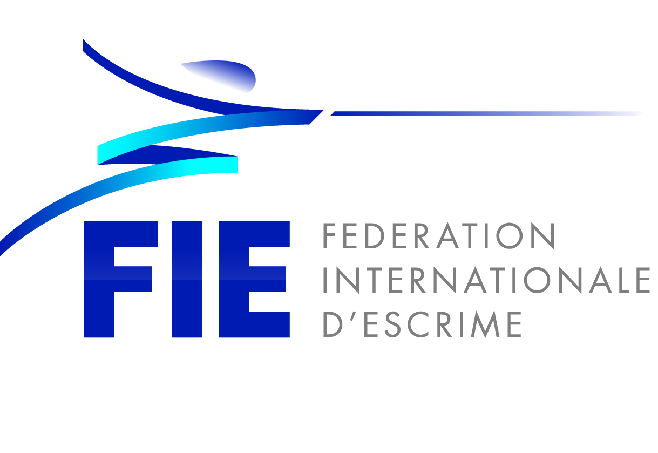
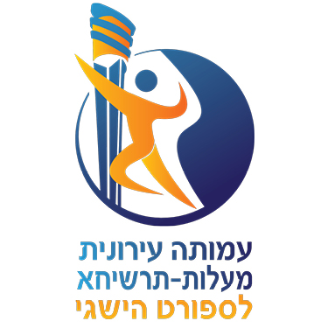
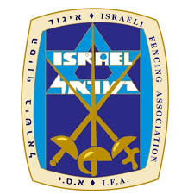

Peace Cup Satellite

FIE Satellite Women Epee
26.10.2019

Dear Friends,

It is with great pleasure that I invite you to the Peace Cup Satellite on behalf of Israel Fencing Association, which will be held at the city of Ma'alot–Tarshiha on the 26th of October 2019.

Detail of the competition as follows:

Organisers:
The Federation of Israel Fencing Association
Email: office@fencing.org.il
Site : http://www.fencing.org.il
Mobile: +972-050-5970577
Shalom Cohen Chief Executive Officer

Competition venue
16th HaZait st. , Municipal sport hall of Ma'alot–Tarshiha.

Schedule of the Competition

Saturday 26th of Oct 09:45 Venue open
10:00 Payment / Weapon Control open
11:00 Start of the individual competition
16:00 Semi-finals and final

Participation
Participation is not limited

Entry
Open to all fencers with valid 2019-2020 FIE License.
No fencer is allowed to take part in an official event of the FIE unless he or she is at least 13 years old on 1st of January in the year of the competition.
Entries of fencers, teams and referees can only be made at the FIE website, www.fie.org, respecting the deadlines specified in the FIE Rules (cf. o.54).

Entry fee
Individual competition: 25 euro. The entry fee can be paid at registration before the start of the competition.

Referee Obligation
No obligations

Formula
The Satellite competitions shall use the F.I.E. formula for junior competitions (cf. o.35-o.41) except that:
- If there is a pre-tournament in which all the participants to the satellite tournament take part, the composition of the round of pools of the satellite competition will be based on the results of this pre-tournament (the composition of the pre-tournament pools shall use the satellite rules).
- The organizers shall have the right to organize additional bouts in order to establish the final classification for places 9 onwards. In this case, the classification (9+) will be based on these additional bouts.

Accommodation and Transport

Kindly contact by email to ferdman_yaaqov@walla.com or Sport-1@maltar.co.il No later than 10th of October 2019 if you wish to avail of the special hotel rates provided by the Organizers.

Hotels:

Hacienda Forest View Hotel
https://www.c-hotels-israel.com/hacienda-forest-view-hotel

Olive hotel Nahariya
http://www.olivebb.com/hotel/Medison-Hotel-Nahariya

Transport
Israel Railway
https://www.rail.co.il/en

Visa Support
Kindly check for visa requirements to the state of Israel before making your ticket reservations.

Further information and contact person

Yaaqov Ferdman in Russian
Telephone: +972-54-7582741
Mobile: +972-54-7582741
Fax: +972-153-4-6469687
ferdman_yaaqov@walla.com

Edan Kfir in English
Telephone: +972-4-6469667
Mobile: +972-52-5188804
Fax: +972-153-4-6469687
Sport-1@maltar.co.il

Warm regards,

Uri Harlap, President

