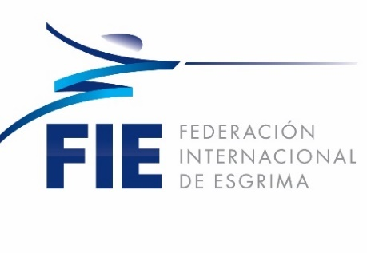

Satellite World Cup
Men´s Foil

Mexico City, Mexico
September 28th & 29th 2019

General Information

Date | September 28th & 29th, 2018
Venue | “Juan de la Barrera” Gym
Address | Avenida División del Norte No. 2333, Colonia General Pedro María Anaya, Alcaldía Benito Juárez, C.P. 03340, Ciudad de México, México.
Organizer | Mexican Fencing Federation
Event | Senior men’s Foil
Participants | Open to all fencers with a valid 2019-2020 FIE license.  Is not allowed for a fencer to be part on an FIE official event unless it’s  13 years old at least on January the 1st of the competition year.
Registry | The candidates must be registered via the web page of the FIE www.fie.org, via their federation, according to the FIE dates and rules  (cf. o.54).
Entry Fee | All participants must pay 30€ per fencer to be paid to the organizers at the moment of registration (FIE Regulations).
Formula | According to FIE regulations
Referees | According to FIE regulations art. o.25
Material | According to FIE regulations

Horario de competencia (aproximado)

Saturday, September 28th
14:00 - 18:00 | Weapons check
12:00 - 14:00 | Registration
14:00 | Poules Publication
Sunday, September 29th
8:00-17:00 | Weapons check
12:00 | Start of Poules
14:30 | Direct Elimination
17:00 | Semifinals and Finals

Registry

- Accreditation must be done on Saturday, September 28th. Before 18:00hrs.
- The accreditation office will be located at the competition venue.

Hotel & reservations information

Holiday Inn Hotel, located 5 minutes away from the competition venue. For hotels information and/or booking you reservation please contact via e-mail to:

Contact: | Ana Elizabeth González
E-mail: | gopa8607@gmail.com
All booking reservation, should be done through this contact to be official and considered to get the organization support

Local Transport

For all the transport information, and booking for transport to the competition venue and airport- official hotel- airport please contact via e- mail to:

Contact: | Ana Elizabeth González
E-mail: | gopa8607@gmail.com
For Airport-Hotel- Airport transport booking please send your Flight information (Time, airline, flight number) arrival and departure with the passengers number with seven days in advance.

The offered transport will be provided as a regular basis schedule and only for the delegations that are registered on the official hotels

Visa

To obtain visas, we ask the national federations to send an e-mail to: fme.esgrima@gmail.com with a passport copy. We will send you then an invitation letter which you will have to submit, accompanied with any required personal identification documents to the Mexican consulate closest to you. To consult the list of the countries requiring visas, please visit: http://www.inm.gob.mx/index.php/page/Paises_Visa

