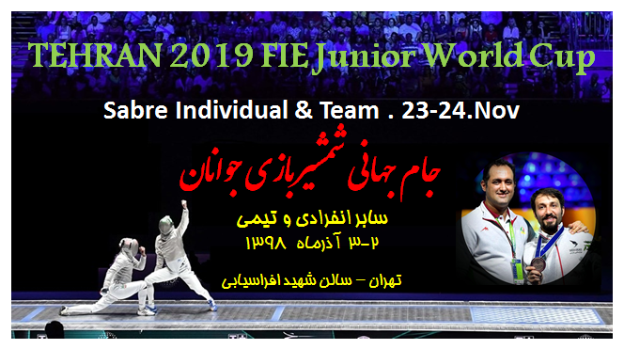
Tehran FIE World Cup

FIE Junior World Cup
“Men’s Sabre, Individual and Team”
23-24 Nov 2019
Dear Friends,

It is with great pleasure that I invite you to Tehran FIE Junior World Cup, on behalf of the Fencing Federation of IRAN, which will be held at Tehran on 23-24 Nov 2019.

Detail of the competition as follows:

Organizers:
The Fencing Federation of IRAN
Tehran,Iran
Telephone:+98 21 26206440
Email: iranfencingfed@hotmail.com

Competition venue
Afrasyabi Sport Hall
Mofateh st, Tehran, Iran

Schedule of the Competition
Friday 22 Nov 14:00 – 21:00 Registration / Weapon Control

Saturday 23 Nov 08:00 Venue open
08:30 Payment / Weapon Control open
10:00 Start of the individual competition
16:00 Semi-finals and final

Sunday 24 Nov 08:00 Venue open
08:30 Payment / Weapon Control open
10:00 Start of the team competition
16:00 Final

Participation
Alt 1. Each national federation may enter a maximum of 12 fencers.
Alt 2. The organising country may enter up to 30 fencers plus the number needed to make up the pools.
Team participation is open to all countries and limited to one team per weapon per country.

Entry
Open to all fencers with valid 2019-2020 FIE License.
No fencer is allowed to take part in an official event of the FIE unless he or she is at least 13 years old on 1 January in the year of the competition.
Fencers taking part in all the official FIE Junior competitions, individual or team, must be under 20 years old at midnight on 31st December of the year preceding the year in which the competition takes place (cf o.80)
Entries of fencers, teams and referees can only be made at the FIE website, www.fie.org, respecting the deadlines specified in the FIE Rules (cf. o.54).

Entry fee
Individual competition: EUR 25. Team competition: EUR 150
The entry fee can be paid at registration before the start of the competition.

Referee Obligation
Participating countries must be accompanied by referee with FIE A, B or P licenses as below (cf. t.35). Delegations not respecting the quota must pay a fine of EUR 1000 per referee.

1-4 fencers | No referee required
5-9 fencers | 1 referee
10 or more | 2 referees

Formula
Individual competitions: one qualifying round of pools, a direct elimination table to qualify for a final by direct elimination (cf. o.35-o.41).
Team competitions: Integral direct elimination with a direct elimination table, which may be incomplete. All places in the table up to 16th place will be fought for. From 17th place onwards teams will be classified, within each round of the table, according to their initial place in the table. The first four teams will be placed in the direct elimination table according to the current official team ranking of the FIE (cf. o.86); the remaining ranked teams will be placed in the table by drawing of lots in pairs. The teams that are not classified will occupy the last places in the table, and will be separated by drawing of lots (cf. o.42-o.47).

Doping
Doping control will be done according to FIE rules.

Accommodation and Transport
Kindly contact iranfencingfed@hotmail.com no later than 20th Oct 2019 if you wish to avail of the special hotel rates provided by the Organizers.

Marlik Hotel (****) Morvarid Hotel (***) Hotel Parsian (*****)
600 m 1.5 km 10 km / 20 min
Single room : 65$ single room : 55 $ single room : 80 $
Double room: 75$ double room : 65 $ double room: 95 $
Triple room: 90 $ triple room : 80 $

Visa Support
Kindly check for visa requirements to IRAN before making your ticket reservations. Those who need visa assistance and/or visa support, please contact iranfencingfed@hotmail.com no later than 20 Oct 2019.

Entry form
Federation:……………………………………
 | Sure Name | First Name | Father’s Name | Passport No | Date of issue | Date of Birth | Date of expiry | Position
1
2
3
4
5
6
7
8
9
10

Further information and contact person
Iran Fencing Federation, 3rd floor, unit 6, Ansari St ,Nelson Mandela St, Tehran ,Iran.
iranfencingfed@hotmail.com
Tel: +98 21 26206440
Mobile: +98 912 6952393
Fax: +98 21 26206430

Warm regards,

Dr. Fazlollah Bagherzadeh
President of Iran Fencing Federation

