AFRICAN Cadet and Junior Championships

CAPE COAST (GHANA)

From 24Th to 29Th of February 2019

INFORMATION FOR DELEGATIONS

General and specific rules of Championship

- The competitions are organized in principle according to FIE Rules in force. However, smooth running of competitions can require adopting appropriate.
- ENTRIES: all fencers must have a valid FIE license 2019-2020, and entry for junior individual and team is via the FIE website before 18th February 2020
- Cadet and under 15 entry is by the CAE website.
- Venue: University of Cape Cost Sports Hall
- Competition Fees: €15 Euro for Individual and €50 Euros for team.
- Weapon control is daily between the of hours 8 am to 4pm at the event Hall (UCC)
- Referees: each participating counties with more than four fencers will have to provide one referee at their own expense, while the organizers will provide local transport, hotel, and feeding for the duration of the tournament.
- You can contact the organizer for any assistance for visa support via email: ghanafencing@gmail.com or capevisa@gmail.com and on Phone:+233243642681 /+233204190932

Visas and visa requirements
In case that you need visa for Ghana the following requirements must be met:
- Passport Requirements: Original, signed passport valid for 6 months beyond stay in Ghana, with at least one blank passport page available for Ghana visa stamp. Amendment pages in the back of the passport are not suitable for a Ghana visa.
- Ghana Visa Application Form: Two Ghana visa application forms.
- Photo Requirements: Two recent 2 x 2 passport type photographs, in color, front view and with a plain/white background. 4
- Letter Of Invitation
- Proof of Travel Arrangements: Computer generated flight itinerary from the airline or a travel agency or copy of airline ticket showing entry and departure from Ghana.
- Hotel Confirmation
- Medical Requirements: All persons entering Ghana are required to have a valid certificate of immunization against yellow fever. The vaccination should be made at least 10 days prior to entry, and should be renewed every 10 years.

The Official Schedule
22nd of February – Arrival of delegations
- 16:00 – 19:00 Accreditation and Weapon Control Cape Hotel

23Rd of February – arrival of Delegations and Meetings
- 08:00 - 20:00 Accreditation and Weapon control Competition Venue
- 17:00 Meeting of the Directoire technique Cape Hotel 17:00

24Th of February (Day 1): Cadets
INDIVIDUAL MEN’S EPEE 09:00 am Starting of elimination round
INDIVIDUAL WOMEN’S FOIL 12:00 pm Starting of elimination round
INDIVIDUAL MEN’S SABRE 15:00 pm Starting of elimination round

25Th of February (Day 2): Cadets
INDIVIDUAL WOMEN’S EPEE 09:00 am Starting of elimination rounds
INDIVIDUAL MEN’S FOIL 12:00 pm Starting of elimination rounds
INDIVIDUAL WOMEN’S SABRE 15:00 pm Starting of elimination rounds

26Th of February (Day 3): Juniors
INDIVIDUAL MEN’S EPEE 09:00 am Starting of elimination rounds
INDIVIDUAL WOMEN’S FOIL 12:00 pm Starting of elimination rounds
INDIVIDUAL MEN’S SABRE 15:00 pm Starting of elimination rounds

27Th of February (Day 4): Juniors
INDIVIDUAL WOMEN’S EPEE 09:00 am Starting of elimination rounds
INDIVIDUAL MEN’S FOIL 12:00 pm Starting of elimination rounds
INDIVIDUAL WOMEN’S SABRE 15:00 pm Starting of elimination rounds

28Th of February (Day 5): Teams
MEN’S EPEE TEAM 09:00 am Starting of elimination rounds
WOMEN’S FOIL TEAM 09:00 am Starting of elimination rounds
MEN’S SABRE TEAM 11:00 am Starting of elimination rounds
WOMEN’S EPEE TEAM 11:00 am Starting of elimination rounds
MEN’S FOIL TEAM 13:00 pm Starting of elimination rounds
WOMEN’S SABRE TEAM 13:00 pm Starting of elimination rounds

29Th of February (Day 6): Teams UNDER 15
MEN’S EPEE TEAM 09:00 am Starting of elimination rounds
WOMEN’S FOIL TEAM 09:00 am Starting of elimination rounds
MEN’S SABRE TEAM 11:00 am Starting of elimination rounds
WOMEN’S EPEE TEAM 11:00 am Starting of elimination rounds
MEN’S FOIL TEAM 13:00 pm Starting of elimination rounds
WOMEN’S SABRE TEAM 13:00 pm Starting of elimination rounds

Hotel Forms
1.
Beach hotel | Cost | Number of Rooms | Arrival Date and time | Departure date and time
SINGLE ONE IN A ROOM | €100
DOUBLE TWO IN A ROOM | €65 each
EXERCUTIVE | €120

2.
Hotel cape | COST | Number of Rooms | Arrival Date and time | Departure date and time
SINGLE ONE IN A ROOM | €80
DOUBLE TWO IN A ROOM | €45 EACH
EXERCUTIVE | €100

3.
HOTEL BK | COST | Number of Rooms | Arrival Date and time | Departure date and time
ONE IN A ROOM | €80
TWO IN A ROOM | €45 EACH
EXERCUTIVE | €100

The Cost above includes breakfast, lunch, Dinner and transport from Airport to hotel.
All the food are halal please also notify as if vegetarians in your team.

All payments for Hotel and participation fees are to be made in cash to the organizers at the hotel or at the Ghana Fencing Office at the Venue on day one of the arrival.

Participation fees: individuals € 15Euros and € 50Euros for team
SPECIAL ARRANGED TOUR TO CAPE COAST & ELMINA CASTLE AND KARKOM CANOPY WALK @ € 15Euros Please return this before December 26th 2019

Beach hotel
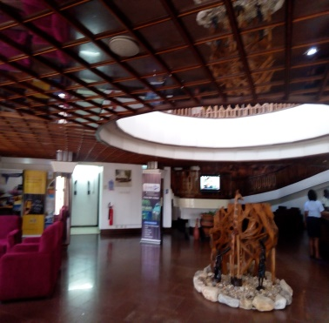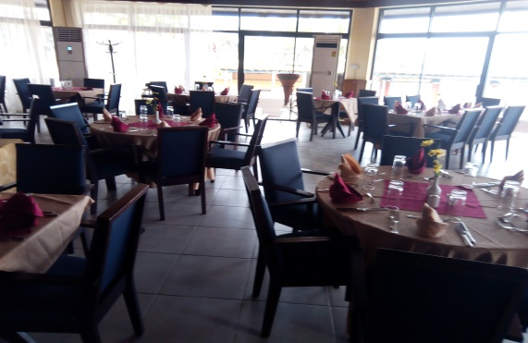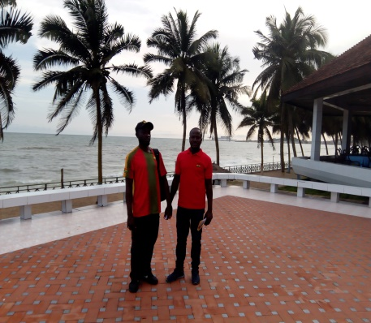
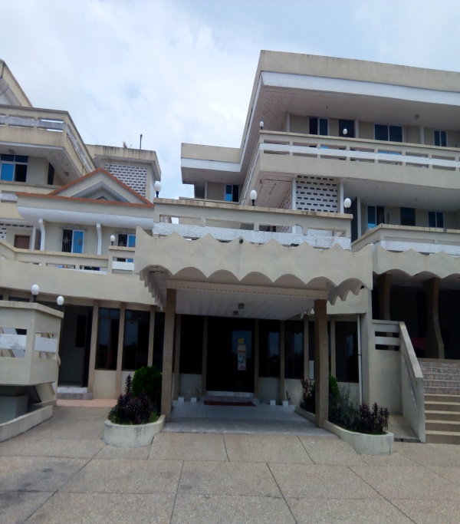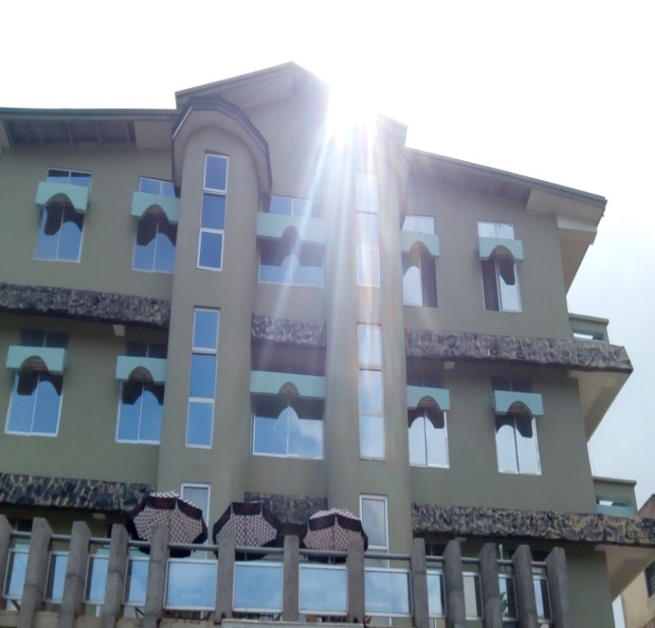
CAPE HOTEL BK HOTEL
L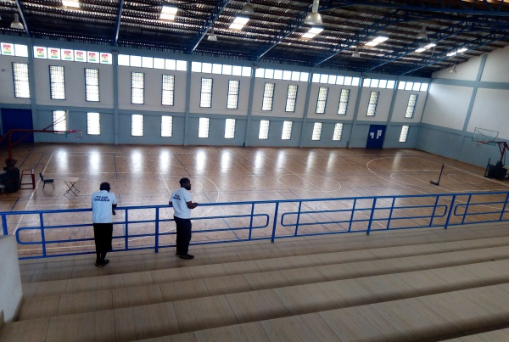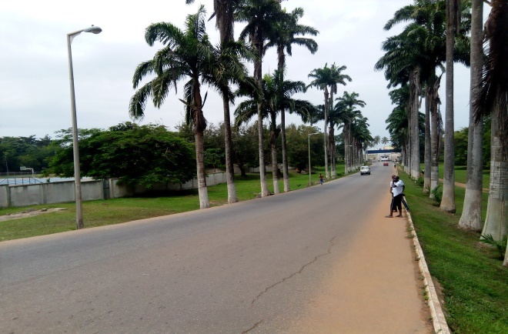

CAPE COST 2020 CADET JUNIOR AFRICA FENCING CHAMPIONSHIP GHANA

FEDERATION NAME: ………………………………………………… DATE: ………………………. SIGN………………………
NAME: AS IN PASSPORT | DATE /BIRTH | PASSPORT No | GENDER | WEAPON | FLIGHT NUMBER | ARRIVAL DATE DEPATURE | DEPARTUR

OFFICIALS
CAPE COST 2020 CADET JUNIOR AFRICA FENCING CHAMPIONSHIP GHANA
FEDERATION NAME: ………………………………………………… DATE: ………………………. SIGN………………
NAME: AS IN PASSPORT | DATE /BIRTH | PASSPORT No | GENDER | FUNCTION | FLIGHT NUMBER | ARRIVAL AND DEPATURE DATE

