Manual for FIE chips
(uniform, plastron, mask).
Chips (tags) should be placed only on equipment certified by FIE!
Special labels are designed for the equipment containing chips: Figure 1 – for suits or plastron, Figure 2 – for masks.
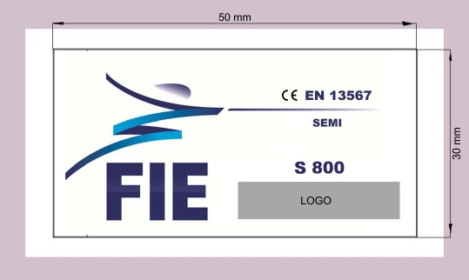  Fig.1 | 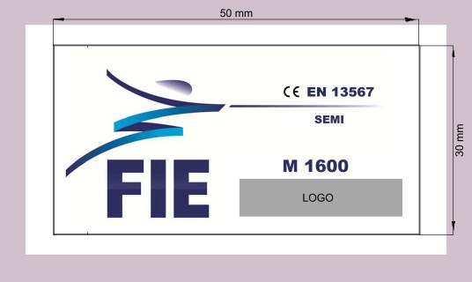  Fig.2
LOGO – manufacturer logo space.
Attention: you will require mobile phone with NFC to read the chips.
- Take your smartphone and enable NFC module.
- Bring your smartphone closer to the chip located on the equipment under the label.
- If everything is done correctly, your smartphone will display website “https://brand-defence.com/..”
- On the website you will see the information about the chip you’ve read, for example:

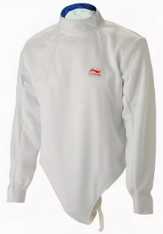
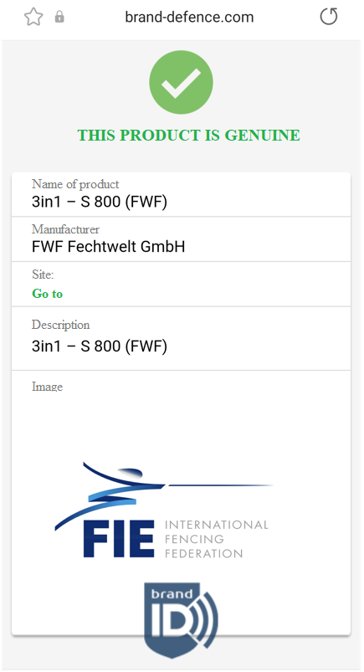

Website can differ depending on your region and language of the smartphone.
To provide the necessary level of counterfeit protection it is recommended to use mobile app “BrandDefence”:
For Android:https://play.google.com/store/apps/details?id=com.BrandDefence.BrandDefence
For iOS: https://apps.apple.com/us/app/brand-defence/id1403725121
More information on NFC technology and principles of operation can be found at:
Android: https://developer.android.com/guide/topics/connectivity/nfc
iOS: https://developer.apple.com/design/human-interface-guidelines/ios/user-interaction/near-field-communication/

