WELCOME TO NOVI SAD - SERBIA

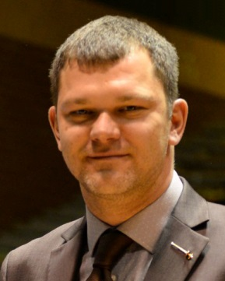
Dear friends, colleagues, coaches and fencers,
It is with great pleasure that we, once again, host a Europe’s best of the best junior and cadet fencers. We welcome You all to Novi Sad, second biggest city of Serbia and one of gastronomical and cultural capitals of this part of Europe.
It is now a tradition of our Federation to host big competitions, advance and develop organization, and provide unique experiences for our European fencing family. As always, we will do our best to make your competition smooth, safe and with best possible conditions for your best possible results.
Through these difficult times, where we are hostage of COVID infection, we strive to act professionally and responsibly, which in emotion filed sport like fencing is not always easy. The organizing of these Championships was one of the hardest that our federation has ever done, primarily because of desire to keep everyone safe without disrupting them in any way, or limiting their freedoms, which is a hard, if not impossible task. We hope that procedures and protocols we have set for your safety will not influence your good results and we ask you to follow them to the full extent!
I wish you good health, good performance, good results, sport luck and, of course, a good time in our beautiful country.

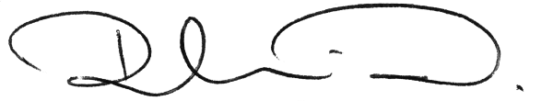

Dejan Ruski
President
Serbian Fencing Federation

Contents

ABOUT NOVI SAD 5
I. General info 5
II. Weather and Climate 5
III. Emergency phones 5
IV. Power and electricity 5
V. Currency 5
VI. Public transportation and taxi 5
ENTRY AND VISA FOR SERBIA 6
I. General entry requirements for Serbia 6
II. Visa 6
III. COVID related requirements 6
VENUE 7
REFEREES 8
COMPETITION SCHEDULE 9
ENTRY FEE 10
WEAPON CONTROL 10
TRANSPORT 11
ACCOMMODATION 11
LIVE STREAMING AND LIVE RESULTS 11
FENCING LINK 12
COVID PROTOCOL 13
Introduction 13
General COVID information 13
I. General protection measures 13
II. Most common COVID-19 symptoms 14
III. Close contact 14
Serbia and COVID: 14
COVID and fencing 15
Championships COVID protocol 15
I. Before Travel 15
II. Arrival and airport transport 16
III. Testing and bracelets 16
IV. Bracelets and retesting 16
V. Accommodation 17
VI. Transport form hotel to the venue 17
VII. Positive COVID-19 test result 17
VIII. Positive COVID-19 test result and close contact 18
IX. Developing symptoms during competition 18
X. COVID Testing fees and results communication 18
XI. Testing points working hours 18
XII. Movement in “SPENS” during competition 19
XIII. Disciplinary measures 19
XIV. Return test 19
CONTACT 20
TRANSPORT FORM 21
RETURN COVID TEST SCHEDULING FORM 22
APPENDIX B 23
APPENDIX C 25

ABOUT NOVI SAD

General info

Novi Sad is the capital of the northern Serbian province of Vojvodina and the administrative center of the South Bačka District. The city is located on the border of the Bačka and Srem regions, on the banks of the Danube river and Danube-Tisa-Danube canal facing the northern slopes of Fruška Gora mountain. Novi Sad is located 70 km away from Belgrade, and connected by an international highway with Budapest, Vienna, Belgrade, Athens, Bucharest and Istanbul. The closest international airport is Belgrade airport “Nikola Tesla” which is around 70 km away by highway.
Novi Sad is the second largest city in the Republic of Serbia with around 350,000 citizens.

Weather and Climate

Novi Sad has a continental climate. The average temperature in February is between 0.5C and 6.4C. In this period, in average there is 9.8 days of rain (source HMZ Serbia).

Emergency phones

POLICE - 192
FIRE DEPARTMENT - 193
AMBULANCE - 194

Power and electricity

In Serbia the power sockets are of type F, C, E. The standard voltage is 230 V and the standard frequency is 50 Hz.
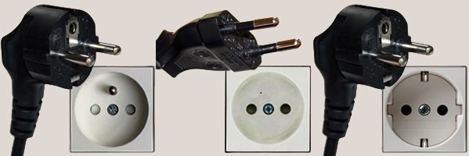

Currency

Serbian currency is dinar. For one Euro it is possible to get around 117 dinars.

Public transportation and taxi

Public transportation is available only by busses circulating on predefined lines. The price of ticket in public transport is 65 dinars and can be bought in any bus (only cash). For instruction on how to get to some location please advise receptionist in your hotel.
There are many Taxi companies in Novi Sad. The maximum fee should not exceed 1000 dinars from any point in town, during the day.

ENTRY AND VISA FOR SERBIA

General entry requirements for Serbia

- A valid travel document, or a valid identity card if so provided for under a bilateral agreement or by a Decision of the Government of the Republic of Serbia.
- Valid visa in the passport, if a Serbian visa is required for passport holders of the respective country
- Proof of sufficient funds for staying in Serbia. Sufficient funds are considered to be 50 Euros per day of stay, proved by possession of the appropriate amount of cash, bank statement, traveler’s cheques, credit cards or a letter of guarantee
- Certificate of Covid-19 vaccination or certificate of recovery of Covid-19 or Covid-19 negative PCR test (see COVID related requirements).
- If underage children are travelling with one of their parents, it is necessary to submit a relevant certified authorization by the other parent; or if the child is travelling with a third person such authorization is required from both parents or guardian
- It is recommended to have a health insurance for the period of stay in Serbia, covering possible medical costs to the amount of not less than 20,000 Euros.

Visa

Before travelling to the Republic of Serbia, please check here whether you need a visa. The information can be found on this link
If you do need a VISA, general visa requirements can be found here.
Diplomatic-consular mission of the Republic of Serbia reserves the right to request additional documentation. Incomplete applications will not be accepted.
For more information regarding the issuance of visa, please contact the nearest diplomatic-consular mission of the Republic of Serbia.

COVID related requirements

Republic of Serbia does not have classification of the countries based on incidence, number of infected people per capita, type of COVID virus or similar. Foreign citizens are allowed to enter the Republic of Serbia provided that they have one of the following documents:
- Negative RT-PCR test
- Certificate of complete vaccination (non-EU countries)
- Certificate of overcome COVID-19 disease
- EU digital certificate

Requirements for entering Serbia in regard to COVID can be found on the website of Ministry of foreign affairs of republic of Serbia here in the section “ENTRY REGIME FOR FOREIGN CITIZENS”. Check this link regularly before your trip and inform us if You have any issues.

VENUE
Competition will be held in:
SPC Vojvodina “Spens”
Sutjeska 2
21000 Novi Sad

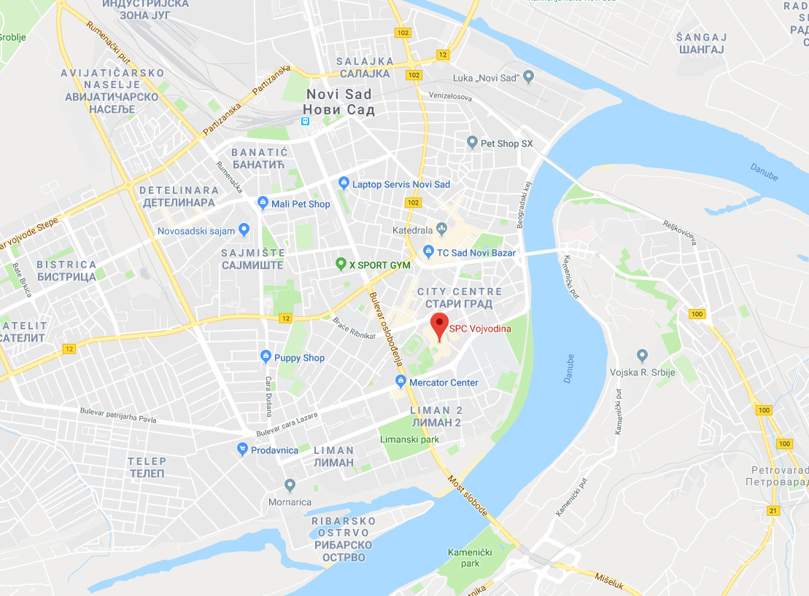

SPC Vojvodina “Spens” - location in Novi Sad

REFEREES
 |  |  |  | FIE category (A,B)
No | Federation | Family name | First name | Foil | Epee | Sabre
1 | BEL | OOSTERBOSCH | Thibault | B | B | B
2 | BUL | STOYCHEV | Julian | B |  | B
3 | CRO | MIJATOVIC | Bojan |  | B | B
4 | CZE | SRNA | Jan | B | B
5 | DEN | HEJRSKOV | Mads Vetli | B | B
6 | ESP | CASARES | Ignacio | B | B | B
7 | EST | OSTROVSKI | Denis | B | B
8 | FRA | LIMBARDET | Christophe | B |  | B
9 | GBR | LENNON | Christopher | B | B
10 | GEO | APTSIAURI | Tatia |  | B | B
11 | GER | GASPER | Christian | B | B
12 | GRE | GEROSSIDERIS | Efstathios | B | B
13 | HUN | VARGA | Katalin | B | B
14 | IRL | STEACY | Sarah |  | B
15 | ITA | DAL POZZOLO | Marco | B | B
16 | LTU | PALCINSKAS | Mindaugas |  | B
17 | NOR | BORSODI | András | B | B
18 | POL | GNIEWKOWSKI | Marek | B |  | B
19 | ROU | DOANA | Andreea | B |  | B
20 | RUS | ROGUSHKIN | Maxim | B | B
21 | SUI | AMEZ-DROZ | Léon |  | B
22 | SVK | CELLER | Pavol | B | B
23 | SWE | GORAL | Tomasz | B | B | B
24 | FIN | PRUGINIC | Dimitar |  | B
25 | TUR | ORAY | Cem | B |  | B
26 | SLO | JEZA | Jure |  | B
27 | SRB | KOVAČEVIĆ | Miljan | B | B | B
28 | SRB | KOVRLIJA | Ana | B | B
29 | SRB | ILIĆ | Danijela | B
30 | KUW | ALSHAMALI | Rashed | B | B | B
31 | KAZ | TILENSHIYEV | Yeraly | B | B | B
32 | MEX | MORALES | Jackobo |  | B | B
33 | SIN | CHUA | Eugene Wee Hong | B | B | B
34 | USA | DECKER | Laura | B |  | B
35 | CHN | QIAO | Min | B |  | B

COMPETITION SCHEDULE
Program of the events (provisional, details can be changed accordingly to real participation)
25th February 2022 | 9:00 | - Accreditation and weapon control
 | 15:00 | - Meeting of the Directoire technique on the venue
 | 17:00 | - European Cadet Circuit meeting
 | 19:00 | - Seminar and meeting of referees
26th February 2022 | 19:00 | - Foil women juniors | individual | ceremony 18:00  Finals 18:30
 | 12:30 | - Saber men juniors | individual
27th February 2022 | 9:00 | - Foil men juniors | individual | Finals 18:00
 | 11:00 | - Epee women juniors | individual
28th February 2022 | 9:00 | - Epee men juniors | individual | Finals 18:00
 | 11:00 | - Saber women juniors | individual
1st March 2022 | 9:00 | - Epee women juniors | team | Finals 16:00
 | 9:00 | - Foil women juniors | team
 | 12:00 | - Saber men juniors | team
2nd March 2022 | 9:00 | - Epee men juniors | team | Finals 16:00
 | 9:00 | - Foil men juniors | team
 | 12:00 | - Saber women juniors | team
3rd March 2022 | 9:00 | - Foil women cadets | individual | Finals 18:00
 | 13:00 | - Saber men cadets | individual
4th March 2022 | 9:00 | - Foil men cadets | individual | Finals 18:00
 | 11:00 | - Epee women cadets | individual
5th March 2022 | 9:00 | - Epee men cadets | individual | Finals 18:00
 | 12:30 | - Saber women cadets | individual
 | 9:00 | - Epee women cadets | team | Finals 16:00
6th March 2022 | 9:00 | - Foil women cadets | team
 | 12:00 | - Saber men cadets | team
 | 9:00 | - Epee men cadets | team
7th March 2022 | 9:00 | - Foil men cadets | team | Finals 16:00
 | 12:00 | - Saber women cadets | team

ENTRY FEE
Entry fee individual: 120€
Entry fee team: 140€
Payment is possible by cash in the venue or by bank transfer. For bank transfer please contact payment@mss.org.rs with request for proforma with bank details. Request should contain list of names of the fencers for whom the payment is made.

WEAPON CONTROL

Weapon control will be available from 25th of February to 5th of March, from 08:00 – 15:00 in the venue. Note that weapon control will not be possible without accreditation. When applying your bag to weapon control, please make sure it contains only fencing equipment. You can check the status of your bag via Fencing link™ application.
The maximum numbers of equipment pieces are:

Equipement / Equipment | Maximum pcs
Epée / Epée | 4
Fleuret / Foil | 4
Sabre / Sabre | 4
Fils de corps fleuret, sabre / Bodywire foil, sabre | 3
Fils de corps épée / Bodywire épée | 3
Fils de masque / mask wire | 3
Veste électrique fleuret / foil lamé | 2
Veste électrique sabre / sabre lamé | 2
Pantalon / breeches | 2
Sous cuirasse / plastron | 2
Veste / jacket | 2
Gant fleuret, épée / foil, epee glove | 2
Gant sabre / sabre glove | 2
Manchette sabre / sabre overlay | 2
Masque épée / épée mask | 2
Masque fleuret / foil mask | 2
Bavette fleuret / foil bib | 2
Masque sabre / sabre mask | 2
Bavette sabre / sabre bib | 2

TRANSPORT
Transport from Belgrade airport to official hotels in Novi Sad and back is available. Transport price is 65 € per person. Please make sure you read COVID instructions for transport.
To book the transportation please go to the official Championship page:
www.fencingns2022.com
or fill in the form at the end of the invitation letter and send it to echtransport@mss.org.rs .
Transportation from hotel to venue and back is available only for official hotels. Daily schedules will be available on official web page, hotel lobbies and via application Fencing link™.

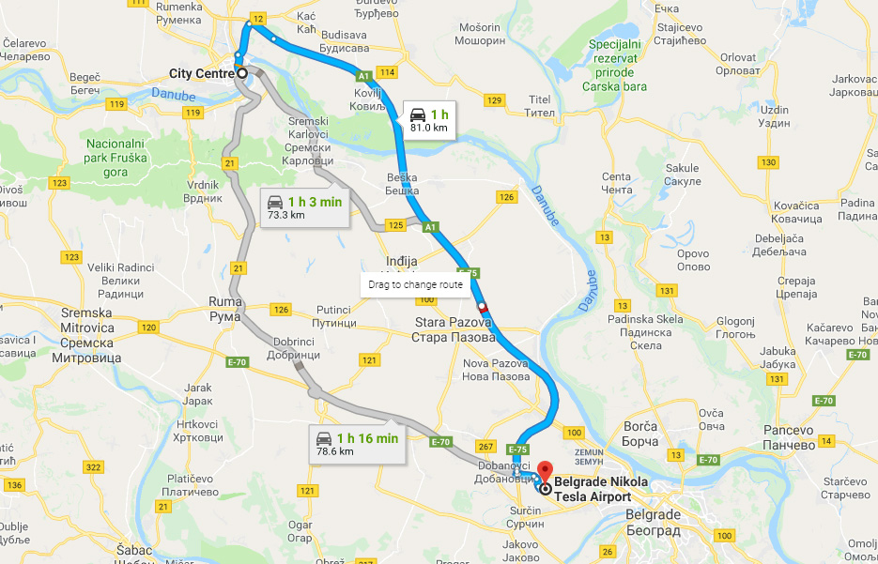
Highway from Airport “Nikola Tesla” to Novi Sad

List of official hotels and reservation form is available on the official Web page:

ACCOMMODATION
www.fencingns2022.com
or you can contact the official agency handling the accommodation process.
Please note that transportation from hotel to venue and back is available only for official hotels.

LIVE STREAMING AND LIVE RESULTS

Live streaming and live results can be found on the official webpage:
www.fencingns2022.com

FENCING LINK
This competition will be using Fencing Link™.
Fencing link™ is three step software system that enables smooth running of the initial processes of the fencing competition: payment, accreditation and weapon control. It also enables easy distribution of important information to all competitors and officials.
First step is payment. It can be done by single competitor or by one official for all the competitors from one country. All the other steps rely on this one. You will not be able to take the accreditation without paying and you will not be able to submit your material to weapon control.
Second step is accreditation. You can only get your competitor accreditation if your entry fee is payed! If you have your picture on FIE webpage you will have your accreditation already done, if not one will be made immediately on the spot. Whole process takes about two minutes.
Third step is weapon control. You can submit your equipment ONLY with accreditation and only in a bag that contains ONLY material for the weapon control i.e.:
This way we can ensure that your weapon control is fast and on time. You can follow the status of your bag on screen next to weapon control or on the mobile phone (see manual below) and on your confirmation slip you can see the expected time of delivery for your bag.
Fencing link™ also provides useful information at any moment for all the competitors and officials. Simply scan QR code on your Accreditation with your mobile phone and you will receive personal welcome with all the information regarding competition schedule, transfer schedule, results, live streaming and information about your bag in weapon control. The application is web based so you can use it anywhere where there is internet connection.

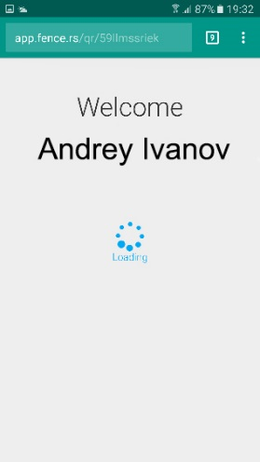
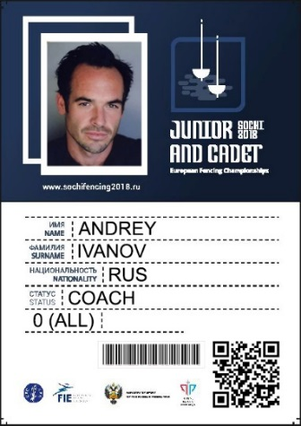
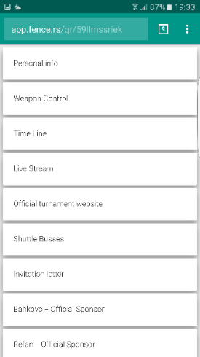
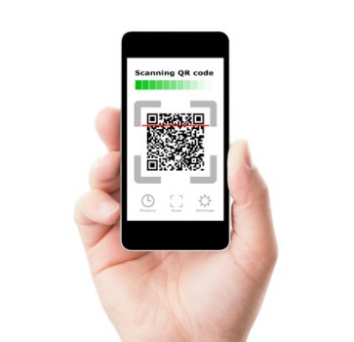

COVID PROTOCOL
Introduction
The Serbian Fencing Federation and local organizing committee has developed this COVID-19 Protocol and Protection Plan which establishes the principles, protocols, and general guidelines to be followed by all participants before and throughout the Championships. This document aims to inform participants about the measures put in place to reduce the possibility of viral transmission to a minimum during the Championships.
These measures complement the sanitary requirements prescribed by public authorities of Republic of Serbia.
Please take time to understand the plan, steps you must take and the rules you must comply with before you travel and throughout the length of your stay in Novi Sad and Serbia. It’s crucial that you take personal responsibility for your part in the plan.
The health protocol applied to the public will be established according to the obligations presented by the competent authorities.
Given the changing nature of the COVID-19 pandemic, the Championship’s COVID-19 Protocol and Protection Plan is a dynamic document that is subject to change in response to any circumstances that may arise prior to or during the Championship.
This document is binding to all officials (FIE staff, EFC staff, team officials, judges, guests) and athletes registered for competing or otherwise participating in the competitions.

General COVID information

  - General protection measures

All participants taking part in the Championships are expected to abide by the following practices, regardless of their function and role, in order to protect themselves and other participants:
    - Wash/sanitize your hands frequently, especially if you have had contact with another person or an object of common use and when you enter a new area.
    - No handshakes. Use a contactless greeting.
    - Always wear a face mask when outside of your hotel room, changing the mask every 4 hours and/or if the mask is soiled or damp (WHO). It is important you make sure you have access to enough face masks (surgical masks) to last through your stay in Serbia. Everyone is responsible for their own supply.
    - Proactively monitor their health for any COVID-19 symptoms (WHO)
    - Always cough into your mask, sleeve or a tissue.
    - Maintain social distancing as much as possible (minimum 1,5 meters), especially during mealtimes and on transportation services. Avoid meetings in small areas.
    - Sanitize/disinfect personal items frequently, including your mobile phone, accreditation, water bottle, pens, etc.
    - Avoid sharing your personal items with others (mobile phone, water bottle, pens, etc.).
    - Always wear your accreditation to confirm that you are participant of the Championships (hotel, transport, and venue).
    - Carefully respect all instructions and requirements set forth by the Organizers and Republic of Serbia.
    - Strictly follow Championships principle of operations for the best protection of all participants.
    - Any activity or travel outside of the Championships is prohibited. If an emergency arises, any travel or activity outside of the Championships must be declared and validated by the Championships COVID manager.

  - Most common COVID-19 symptoms

COVID -19 COVID-19 symptoms include the following (refer to the WHO for more details):

    - Fever of 37.9 ° C or more
    - Cough
    - Sore throat
    - Shortness of breath
    - Muscle pain
    - Headache
    - Diarrhea and / or vomiting
    - Sudden loss of taste and / or smell.

Close contact

A person that was in “close contact” with infected person is anyone who was in close contact (face to face) with a probable or confirmed case of Covid 19 within 1 meter and for at least 15 minutes.
If a participant is considered to be in a “close contact” with a infected person he/she will have to be isolated and tested. If his/her test is negative, the participant can stay in the Championship.

Serbia and COVID:

COVID related conditions for entering Serbia can be found here. Republic of Serbia does not have classification of the countries based on incidence, number of infected people per capita, type of COVID virus or similar. General protection procedures stated in previous segment of this document are advised. In Serbia it is mandatory to maintain social distance and wear masks indoors. After 20:00h, entering coffee shops, restaurants and bars is possible only with an EU or Serbia issued certificate of:
- Vaccination (Pfizer, Moderna, AstraZeneca, Sputnik V, Sinopharm ) or
- negative PCR test done in last 72h or
- negative antigen test done in the last 48h or
- overcome COVID-19 in the last 6 months.
There are no other restrictions.

COVID and fencing

COVID Rules:
FIE rules stated in FIE outline risk-mitigation Covid-19 regulations will be applied for both cadet and junior categories.

COVID Forms:
To participate on the competition please refer to FIE outline risk-mitigation Covid-19 regulations.
We remind you to have Form B COVID-19 acknowledgment of risk and release from liability signed, scanned and sent to echcovidforms@mss.org.rs or to have it prepared and presented during inscription.
We remind you also to have Form C COVID-19 screening questionnaire for FIE event FIE filled, signed and presented during inscription. Both forms are mandatory for all participants direct or indirect!!

Championships COVID protocol

Before Travel
Participants should ensure they take time to read and understand the steps that must be followed prior to their arrival in Serbia. All direct and indirect participants should:
- Book accommodation and transportation through Organization committee. Any delegations not following this procedure will be denied access to the competition.
- Read this document and fill the Annex B document and send it back to echcovidforms@mss.org.rs
- Monitor their health status continuously, including taking their temperature and monitoring for any symptoms, starting 14 days before the Championship.
- Limit their social interactions as much as possible, starting 14 days before the Championship.
- Make sure they know the latest information regarding COVID-19 testing and certificates required by their airline company.
- Make sure that they have completed the necessary steps should they need to apply for a Visa.
- It is strongly recommended to have travel insurance that covers COVID-19 care.
DO NOT TRAVEL TO SERBIA IF YOU:
- Experience any COVID-19 symptoms within 14 days prior to departure
- Are self-isolating as a result of COVID-19 symptoms or have been in contact with someone who has had symptoms
- Have had a positive PCR test within 14 days prior to departure

Arrival and airport transport

Upon arrival to Serbia, participants must observe the instructions of the Serbian authorities and be ready to show to immigration all documents needed.
Participants coming by plain will be transported to the official hotels for the mandatory upon-arrival Antigen test.
Participants must use the official transportation provided by the Organization committee for arrival/departure and no other private or public transportation means.
During transport, all participants must respect the following requirements:

    - Wearing a face mask is mandatory within official Event transportation.
    - No food/drinks are allowed in transportation.
    - All participants are required to sanitize their hands before entering the vehicle.

During arrival and departure, participants will have to carry their own bags - the driver will not be allowed to touch them. All vehicles will be disinfected at the end of each journey. At the end of each day vehicles will be thoroughly disinfected. Drivers will ensure they have a clean and disinfected vehicle between each trip. Whenever possible, they should open windows of the vehicle to facilitate ventilation. Every vehicle will be large enough to respect social distancing. The transport will be done in small groups (or for complete teams).
Participants coming to Serbia by their own car or minivan will be tested with RAT upon their arrival to the official hotel prior to check-in.

Testing and bracelets

All participants, Direct and indirect will be tested at least once with Rapid antigen test (RAT). Testing will be done in the official hotels. Upon arrival in the hotel, and before check-in, all participants will be taken to the designated room where they will be tested. The results will be done in 15 to 20 minutes. Testing will be done in smaller groups.
Upon negative result they will receive color coded bracelet that have validity of maximum four days.
You can then proceed to check in and other processes (payment, accreditation and weapon control)
Please note that all other procedures (registration, payment, weapon control) will not be possible before testing!
In case of positive result please advise following procedure.

Bracelets and retesting

In accordance to the FIE outline risk-mitigation Covid-19 regulations testing should be done on every four (4) days of stay. to obey this rule, all the bracelets will be color coded for each day of testing and will have a four-day validity. The color codes will be published in the hotels. Persons with expired codes will not be able to enter the venue.
Retesting will be possible in the venue in the specially designated and marked area. Please make sure that you get tested day before your old color code expires.

Accommodation

Participants are strongly recommended to not enter room of other participants (except for Physiotherapy treatments). The use of masks is mandatory in the hotels’ common areas. Physical distancing measures will be implemented throughout the hotel. Sanitizing stations will be displayed near the front entrance and in the common areas. Increased cleaning and disinfecting frequency throughout the hotel, paying attention to frequently touched items. Housekeeping team will change towels and ventilate the room. Participants will have the possibility to display a door hanger should they not wish to have housekeeping enter their room. Hotel staff will follow the hotel protocols. When in hotel restaurants:

    - Use hand sanitizer when entering the dining area.
    - Wear masks at all times, except when eating or drinking.
    - Social distancing must be respected at all times.
    - Tables will be spaced apart and participants should not move the tables and/or chairs.
    - It is advised that members from different teams do not share tables.

Transport form hotel to the venue

Transport from the hotel to the venue will be done in accordance to the schedule and with greater number of vehicles to ensure social distancing. The measures stated here are going to apply.

Positive COVID-19 test result

In the case of a participant gets a positive result for COVID-19 after an antigen test, he/she will have to take a PCR test. If a PCR test is positive, he/she will:
- Be immediately placed into isolation in a single room (at their own cost)
- He/she will be taken immediately to a doctor for examination
- Depending on the doctor’s examination conclusion, actions to be followed will be defined

If a participant has a positive PCR test, he/she will have to be placed in an isolation room at the expense of the participant / travel insurance if applicable, or at the designated hospital if needed. He/she will not be allowed to return to their country of origin until their isolation period has been completed.
The Organizations COVID-19 Manager will follow up on the patient’s situation directly with the relevant Team Manager.
All individuals placed in isolation should be isolated for 7 days and not have any contact with any other individuals during that period. If the participant has a negative PCR test after 7 days of isolation, then the participant can stop his/her isolation.
In case of a positive result on PCR test after 7 days, the participant will continue his/her isolation for another 7 days. This process will continue until negative result.
As a result of any isolation periods, the Organizations COVID-19 Manager will liaise with the hotel and support the National Federation with requirements.
The costs of quarantine, isolation, and medical care are at the expense of delegations/participants.
It is strongly recommended to have an appropriate health insurance to cover routine medical healthcare, including COVID-19 care, hospitalization and, in case of isolation, that such insurance cover has no exclusions or limitations regarding the length of stay, as all costs related to a positive COVID-19 will have to be borne by the participant.
In case a participant is tested positive during the competition, the members of his/her team might be considered as “Close contact”. See definition and consequences on the relevant section above.

Positive COVID-19 test result and close contact

Any person that was in close contact with the COVID positive person shall:

- Be immediately placed into isolation in a single room (at their own cost)
- He/she will be taken immediately to a doctor for examination + have an COVID-19 test
- If the test is positive see procedures stated in previous segment will apply

Developing symptoms during competition

If any participant develops symptoms during competition, he/she shall immediately:

- Inform the Organizations COVID-19 Manager
- Isolate himself at the official hotel in a separate room
- Have a COVID-19 test at the hotel or competition venue (cost to be supported by the participant)

COVID Testing fees and results communication

On arrival RAT costs will be supported by the organizers. Departure and other (symptoms/close contact/PCR test after a positive antigenic test) tests will be supported by the participant. PCR tests are 75€, RAT is 21€.
RAT results will be communicated directly to the participants 15-20 minutes after sampling. PCR test results will be distributed by email and text message to the tested participant within a maximum of 8h.

Testing points working hours

The COVID-19 testing area located in the venue will be open every day from 07:00 to 12:00h.

Movement in “SPENS” during competition

During competition, movement in sport center Spens is going to be limited to specific set of areas: Main hall, final hall, training area, Dressing rooms, processing areas (RAT testing, payment, accreditation and weapon control), catering area and corridors connecting these areas. The routs will be marked visibly. All other areas are off limits and will be closed or the entry/movement will be otherwise prevented.
A refreshment bar will be available in the competition venue for participants, in a specific and exclusive area. Catering staff members will wear face masks at any time and will serve each participant. Specific flow/pathway will be organized in order to reduce gathering. Participants must wear facemasks until they sit in consummation designated areas. Social distancing must be respected at all times. Anyone not eating or drinking must wear a mask.

Disciplinary measures

Serbian authorities are allowed to control if the Sanitary Protocol is followed by all participants. All failure to adhere to the Sanitary Protocol may result to a fine by Serbian authorities.
Possible disciplinary decision will be handled by the organizing committee with the EFC approval.

Return test

In case you need PCR/RAT test for return to your home country please fill in the form on the official webpage or fill in the form from the annex and send it to echreturntest@mss.org.rs .
The cost of return test is on the expense of person getting the test or their federation.
Note that the PCR test can also be done on Belgrade airport 3h-4h before your flight. If you are using our transport services please state in the e-mail that you wish to be tested before flight so the pickup time can be modified accordingly.

CONTACT
For transport:
echtransport@mss.org.rs

For accommodation:
Travel agency OLYMPIC 021 Travel d.o.o.
Tel: +381213029525
Tel: +381638113637
bojan.mavrenski.021@olympic.rs
www.olympic.rs

For all other questions:
Fencing Federation of Serbia
Vukasin Stosic
+381 60 622 61 60
+381 11 3286 165
office@mss.org.rs

www.fencingns2022.com

See you in Novi Sad!!

TRANSPORT FORM

Team/name of competitor:
Number of persons:
Contact phone:
Date of arrival:
Time of arrival:
Arrival flight number:
Flight from:
Date of departure:
Time of departure:
Departure flight number:
Flight to:

*The pickup time for transport to airport will be published in the hotel lobby and via Fencing link system.

Date: _____________

__________________________________
Signature

RETURN COVID TEST SCHEDULING FORM

Name:
Last Name:
Date of Birth:
Country:
Passport Number:
Telephone number:
E-mail Address:
PCR/RAT:
Requested date of test:
Requested time of test:

* Please note that it is necessary to have this form filled for every person from your team that needs PCR/RAT test.

Date: _____________

__________________________________
Signature

APPENDIX B
COVID-19 ACKNOWLEDGEMENT OF RISK AND RELEASE FROM LIABILITY

Name of the Tournament: Junior and cadet European championship 2022
Date: 26th of February - 7th of March 2022

Preamble
The novel coronavirus, COVID-19, has been declared a global pandemic by the World Health Organization. COVID-19 is extremely contagious and experts believe that it is primarily spread through person-to-person contact. The International Fencing Federation, the national fencing federation of the country in which the event is being held and the organizing committee of Junior and cadet European championship 2022 (hereinafter: the “Organizers”) have introduced preventive measures aimed at reducing the spread of COVID-19. Nevertheless, the Organizers cannot guarantee that you will not be infected with COVID-19. Participation may also increase your risk of contracting COVID-19.
* * *
I wish to participate in the tournament (hereinafter: the “Tournament”) as a [Competitor] [Referee] [Armourer] [Member of the DT] [Supervisor] [Coach] [Trainer] [Other: please specify ______________________] (underline as appropriate), and to enter any area in which the Tournament is taking place. As compensation for being permitted to participate in the Tournament, I hereby agree to all the terms of this Release from Liability.
By signing this agreement, I acknowledge the contagious nature of COVID-19 and I voluntarily assume the risk of being exposed to or infected with COVID-19 as a result of my participation in the Tournament. I further acknowledge and voluntarily accept the risk that such exposure or infection may result in bodily harm, illness, permanent disability or death. I understand that the risk of being exposed to or infected with COVID-19 during the Tournament may result from the actions, omissions or negligence of myself and others, including, but not limited to, employees, volunteers and participants in the Tournament.
I voluntarily agree to assume all of the above risks and take full responsibility for any injury (including, but not limited to, physical injury, disability and death), illness, damage, loss, claim, liability or expense of any kind that I may suffer or incur as a result of my participation in the Tournament. I hereby undertake to refrain from suing the FIE and its designated individuals, including, but not limited to, members of the Directoire Technique, Refereeing, Referees, Armorers, supervisor, Video & Wireless Technicians, Announcers, Event Managers, etc. and the Organizers and the employees, agents and representatives thereof, whom I release from all liability. I understand and agree that this release includes all claims based on the actions, omissions and negligence of the FIE and its designated individuals, including, but not limited to, members of the Directoire Technique, Refereeing, Referees, Armorers, supervisor, Video & Wireless Technicians, Announcers, Event Managers, etc. and the Organizers and the employees, agents and representatives thereof, regardless of whether the COVID-19 infection occurred before, during or after my participation in the Tournament.

The release from liability shall be accepted subject to the substantive and/or mandatory laws of the country in which the event is taking place. I agree that, should any part of this agreement be deemed to be invalid or unenforceable, the remaining parts shall remain fully in force. This document shall be governed by the law of the Country of Switzerland and any legal action brought hereunder shall be brought in the courts of Switzerland, which shall have exclusive jurisdiction of any such legal action.

Full legal name ___________________________ Date of birth ___________________________
Address___________________________________________________________________________
Telephone number _____________________ Emergency contact ___________________________
Participant’s signature_____________________________ Date___________________________
SUPPLEMENTARY AGREEMENT FROM A PARENT OR GUARDIAN
(must be completed for participants under the age of 18)

I am the parent or guardian of the minor named above. I understand the nature of the above Release from Liability and I consent to the minor for whom I am responsible participating in the Tournament. I hereby undertake, on behalf of the minor, to refrain from suing the Organizers and the employees, agents and representatives thereof, whom I release from all liability. I understand and agree, on behalf of the minor, that this release includes all claims based on the actions, omissions and negligence of the Organizers and the employees, agents and representatives thereof, regardless of whether the COVID- 19 infection occurred before, during or after the minor’s participation in the Tournament.

Full legal name___________________________
Signature of parent or guardian ___________________________
Date___________________________

APPENDIX C
COVID-19 SCREENING QUESTIONNAIRE FOR FIE EVENT

PARTICIPANT’S NAME: ______________________________________________________________
DOB: _______________________________ MOBILE PHONE: ___________________________
EMAIL: ________________________________ COUNTRY: ________________________________
EVENT: ______________________________ VENUE: ___________________________________
DATE: ________________________
Section 1
Temperature ≥100.1/37.8 | YES NO - Actual Temperature:
Section 2. Do you have any of the following symptoms:
Recent/New Onset Coughing (unrelated to allergy or pulmonary disease) | YES | NO
Recent/New Nasal Congestion (unrelated to allergies or sinus infection) | YES | NO
Recent/New Onset Sore Throat | YES | NO
Recent/New Onset Shortness of breath (unrelated to chronic disease) | YES | NO
Recent/New Onset Diarrhea | YES | NO
Recent/New Onset Abdominal Pain | YES | NO
Recent/New Onset Nausea/Vomiting | YES | NO
Recent/New Onset Fatigue/Malaise | YES | NO
Recent/New Onset of Loss of Taste/Smell | YES | NO
Section 3. Exposure
Are you living with someone who is quarantined? | YES | NO
To the best of your knowledge, have you been exposed to or in contact with someone being tested positive for COVID-19 or who has symptoms compatible with COVID-19? | YES | NO
For information purpose : If you have previously tested positive for Covid-19 and overcame the infection or if you have been fully vaccinated, please take with you the relevant documentation.

Participant’s Signature: _________________________________ Date:__________________

