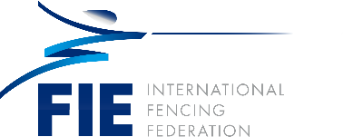

Velichka Hristeva (BUL)

Velichka Hristeva was born on 3rd February, 1954. She trained in fencing from 1968 until 1974, became national champion and holder of numerous medals during this perios.
She graduated high school and two years of coaching school with Mr. Igor Pilnov, head coach, as well as studying business administration at the New Bulgarian University.
She worked as a coach for eight years, and after the political changes in Bulgaria she left coaching to start a small, private company in the private sector.
Since 2002, she has served as President of the Bulgarian Fencing Federation.
As president she has organized the following events and served in various roles:
- 2004 – Grand Prix, sabre men and Junior and Cadet Fencing World Championships
- 2004 – She was elected as a member of the FIE Promotion, Communication and Marketing Commission
- 2005-2009 – Men’s Sabre Grand Prix
- 2008 – Present – member of the FIE Executive Committee
- 2009-Senior European Championships
- 2010-2013 – Men’s Sabre Grand Prix
- 2009-2013 – Member of the Executive Board of the Bulgarian Olympic Committee
- 2014 – Junior and Cadet Fencing World Championships
- 2014-2020 – Junior Sabre World Cup
- 2017 – European Junior and Cadet Fencing Championships Junior and Cadet Fencing World Fencing Championships

