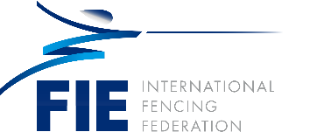

Abdelmoneim Elhamy El Husseiny (EGY)

An experienced analyst with a demonstrated history of working in the management consulting industry in Egypt and the Middle East, skilled in research, financial analysis and modeling. He is a strong business development professional with a certificate in Investment Appraisal, Project Finance and Risk Analysis from CRI Cambridge Resources International and Cairo and Alexandria Stock Exchanges.

Abdel Moneim is a highly qualified banker with more than 30 years of versatile experience spanning over corporate, credit, SME, and consumer banking in leading management roles in a major regional and international banking institution in Egypt and Sudan. He has advanced and updated knowledge of the banking industry markets and practices in Egypt and the Middle East, and is equipped with executive management skills including strategizing, planning, business expansion and boosting as well as professional human staff development.

- Co-founder and partner of an agriculture & animal feed business (Abu Dhabi – UAE)
- Investment appraisal, project finance & risk analysis consultant
- CEO of the Arab Bank, Sudan
- SVP Arab bank Egypt
- Chairman of the Board of Directors of the Egyptian Fencing Federation
- Member of the Egyptian Olympic Committee
- Vice President of the Arab Fencing Federation
- Vice President of the African Fencing Confederation
- Olympic fencer (Los Angeles - Seoul)
- Champion of Egypt, Africa and the Arabs for many years
- International fencing referee
- Member of the FIE Promotion, Communication and Marketing committee

