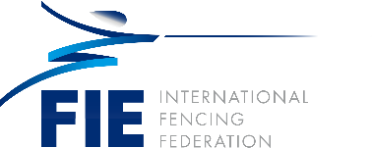

Wang Haibin (CHN)

Education:
- 2005: Undergraduate degree from Nanjing University in French
- 2008: Graduate of Beijing Sport University in Sports Education, Master’s
- 2015: Graduate of Beijing Sport University in Sports Education, Doctorate

Work Experience:
- 1999-2005: Fencing team of Jiangsu Province –
- Athlete 2007-2016: Chinese national fencing team –
- Coach 2017-present
- Chinese Fencing Association President

Athlete
- 1994: Hiroshima Asian Games - Silver medal in men’s team foil
- 1995: World Army Games - Gold medal in men’s team foil
- 1995: National Championships - Gold medal in men’s individual foil
- 1997: Asian Championships - Gold medal in men’s individual foil
- 1998: Bangkok Asian Games - Gold medal in men’s individual and team foil
- 1999: National Championships - Gold medal in men’s individual foil
- 2000: Sydney Olympic Games - Silver medal in men's team foil
- 2001: World Cup - Silver medal in men’s individual foil
- 2002: Busan Asian Games-Gold medal in men’s individual and team foil
- 2004: Athens Olympic Games - Silver medal in men's team foil
- 2005: National Championships - Gold medal in men’s individual foil individual

Coaching
- 2006: Asian Games – Gold medal in men’s team foil
- 2010: Asian Games - Gold medal in men’s team foil
- 2010: World Championships - Gold medal in men’s team foil
- 2011: World Championships - Gold medal in men’s team foil
- 2012: London Olympic Games - Gold medal in men’s individual foil individual (Lei Sheng)

Honor:
- 2010: Best Coach of the Year in China
- Member of the FIE Hall of Fame

