- INVITATION (Version 7 as per 14/12/2022)

A toutes les Fédérations Nationales d’Escrime

La Fédération d’Escrime du Qatar a l’honneur et le plaisir d’inviter votre Fédération à participer au Grand Prix d’Epée masculine et féminin, qui sera organisé à Doha – Qatar, du 27 au 29 Janvier 2023

Nous vous remercions pour votre collaboration et nous nous réjouissons de vous voir parmi nous.

Fédération d'Escrime du Qatar

To all National Fencing Federations

The Qatar Fencing Federation will be pleased to welcome all members of the FIE to participate in the upcoming Fencing Grand Prix Epee men & women, that will take place from 27 to 29 January 2022 in Doha, Qatar.

We thank you for your usual collaboration and we look forward to seeing you in Qatar.

Qatar Fencing Federation

- SANITARY MEASURES – COVID 19 / Specific Rules

Currently, there are no specific rules regarding vaccinations or pre-travel tests for coming to Qatar.
Visitors are no longer required to bring a Polymerase Chain Reaction (PCR) or Rapid Antigen test certificate before traveling to the State of Qatar.​
If updates are made, LOC will inform all participants.

The sanitary measures at FIE competitions have been adapted as follows, until further
notice:

- Wearing a sanitary mask is no longer compulsory, but remains recommended;
- Participants will have to present to the organisers the negative result of a Covid-19 test
(PCR or rapid antigen test), carried out within a maximum of 72 hours before arrival in the
country.

- Entry visa

Entry Visa
To enter in Qatar a compulsory visa for each participant will be issued by Ministry of Interior of Qatar.
The process will be managed by Qatar Fencing Federation.
To obtain the entry visa, participants are requested to fill (by typing) the “Visa Form” and send it as soon as possible by email to visafencing23@gmail.com , at least before January 15th, 2023, at 23:59 pm (UTC +3)
The Local Organizing Committee will take care of the necessary formalities and can’t guarantee the deliverance on time for received request after the deadline.

Contact person :

Visa: Mr Mazin: visafencing23@gmail.com

- COMPETITION INFORMATION

COMPETITION HALL
Aspire Dome: Aspire Zone - Doha, Qatar

TRANSPORT
The Local Organizing Committee will provide the official transportations from airport to the official hotels and to the competition Venue.

PROGRAMME

Wednesday 25/01/2023 Arrival of participants of the men’s & women’s events
All day - scheduled training - Training (Aspire)

Thursday 26/01/2023 Arrival of participants of the men’s & women’s events
09:00 to 12:00 & 16:00 to 20:00 - Training (Aspire)
10:00 to 20:00 - Weapon Control in Hotels

Friday 27/01/2023 09:45 - Fencers Call
10:00 – Poules Women’s ( Pre. DE 64)
10:00 to 20:00 - Weapon Control in Hotels

Saturday 28/01/2023 09:45 - Fencers Call
10:00 - Poules Men’s (Pre. DE 64)

Sunday 29/01/2023 09:00 – DE 64 – Women
10:30 - DE 64 – Men
18:00 – T4 - Women
18:50 – T4 - Men
19:40 – Final Women
20:05 – Final – Men
Monday 30/01/2023 Departure of delegations

For early arrival and late departure, please inform the LOC

ENTRY
The entry of fencers must be done on the FIE web site www.fie.org and entries will be accepted until 7 days before the competition. The entry fee is fixed at 100 € per fencer to be paid to the organizers, by cash or credit card at the moment of registration.

ANTI-DOPING CONTROL

Anti-Doping Control will be done at the end of the tournament under the responsibility of the competition official physician in accordance with the FIE rules.

REWARDS
REWARDS: Prize money Men
Total prize money of US$ 11,000 will be offered as follows:

1st Place: 5,000 US$ | 3rd Place: 1,500 US$
2nd Place: 3,000 US$ | 3rd ex Place: 1,500 US$

REWARDS: Prize money Women
Total prize money of US$ 11,000 will be offered as follows:

1st Place: 5,000 US$ | 3rd Place: 1,500 US$
2nd Place: 3,000 US$ | 3rd ex Place: 1,500 US$

- HOTELS AND MEALS

HOTELS

- Hotel reservation must be done for each delegation only through the Local Organizing Committee before January 15th; 2023 at special rates.
- Booking will be done with the “ACCOMMODATION FORM”
- Participants can be accommodated in single or twin rooms.
- Payment will be done by cash (USD) or credit card upon arrival
- Early check-in (before 3:00 pm) and late check-out (after 12:00 pm) are subject to extra costs.
- After 15/01/2023, in case of “no show” or “cancellation”, 50% of the costs will be charged to the respective federations
- Contact person : Accommodations / Travel: Mr Abdu : hotelsgp23@gmail.com

Marriott Marquis City Center Doha Hotel
Omar Al Mukhtar Street, Area 61, Al Dafna, Street #850, PO Box 25500, Doha Qatar
https://www.marriott.com/hotels/travel/dohmq-marriott-marquis-city-center-doha-hotel

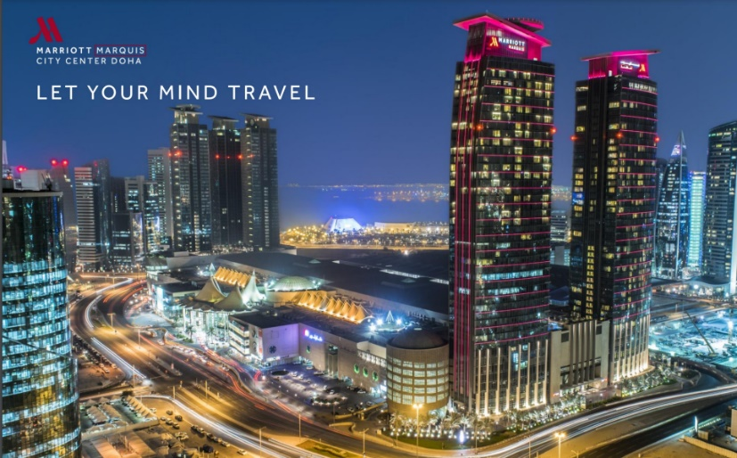

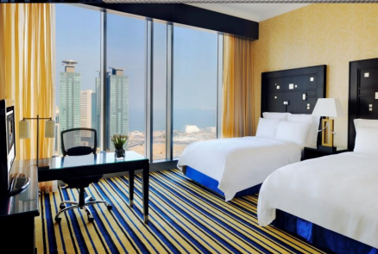

Single room: US$ 150, - /night/room
Double room: US$ 180, - /night/room
These prices include:
- 2 meals
- Local transportation (airport pick up and drop off) – venue
- Visa process

