Referee Examinations – Africa Zone
September 2023

Johannesburg, South Africa

Registration
To register your candidate(s), you must fill in the "Application Form" All applications must be submitted to Natalia Bodrova of the FIE Sports Department: natalia.bodrova@fie.ch and also copied to the CAE Secretary Genera: novak@global.co.za

Information
- Deadline for registration of the candidates for examination is 22 August 2023 12:00 CAE time.
- The maximum number of candidates is 25 per weapon. “First come, first served” selection will be applied.
- All applicants must be at least 20 years old.
- All interested federations must specify in which language their candidates will take the theoretical examination (English, French or Spanish).
- Only candidates who have passed the theoretical examination and the video analysis will be allowed to continue with the practical examination.
- The national federations of the candidates are responsible for the payment of the entry fee, when registering their candidates. In the absence of registration and/or payment of the entry fee, the application will not be considered.
- No candidate may sit for an examination if he/she has not registered by the deadline provided above. No registration will be accepted at the examination venue, even if the registration fee is paid on site.
- The registration fee is €60, to be paid to the FIE. Please note that no applications will be accepted after the deadline and in case of non-payment before the deadline. No payment is needed for the renewal of the license.
FIE Bank details for payment of exam fee:
International Fencing Federation
Banque Lombard Odier & Cie SA
Place Saint-François 11, 1003 Lausanne, Switzerland
Account: 546057 00
IBAN CH10 0876 0000 0546 0570 0
SWIFT code: LOCYCHGGXXX

Venues & Contact Organiser:
- Southern Sun, Rivonia Road, Sandton, Johannesburg, South Africa
- Fencing Federation of South Africa
Tel: +27 72 931 6887
e-mail: secretary@safefencer.co.za

VISA & AIRPORT
- Please check visa requirements for South Africa before making your reservations.
If you require an invitation or assistance with visas, please send copy of passport(s) to secretary@safencer.co.za
AIRPORT: OR Tambo Johannesburg International Airport,

COVID-19 ENTRY CONDITIONS
As at 10 July 2023, there are no Covid requirements for South Africa.

PROGRAMME
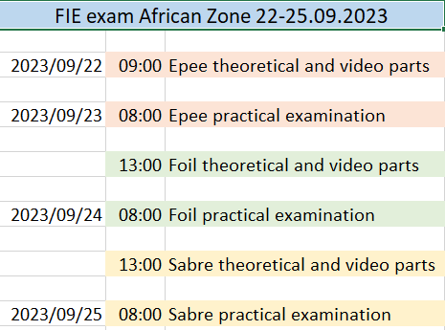

Reception, Accommodation & Transport
Accommodation, as well as the theoretical and video portions of the exam will be held at Southern Sun Sandton. The practical portion of the exam will be held at the South African National Championships.

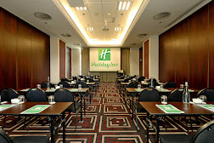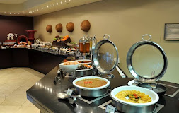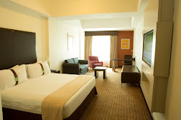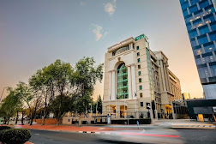
Hotel | Room | €
**** | Single | €110
 | Double | €145

Prices are bed & breakfast. Prices include hotel shuttle to surrounding shopping malls and transport to the competition.
Meals can be arranged in advance at a cost per person:
Lunch or Dinner €15

Airport transfers can be arranged for €32 per person, return.

Accommodation, meals and transfer bookings must be made with the organisers by 1 September 2023.

The payment of all the expenses will have to be done via international transfer against an invoice raised by the FFSA prior to arrival. Due to South African Reserve Bank rules, invoices will be raised in Rands at the prevailing exchange rate.
Credit cards and cheques will not be accepted. All extras are at the charge of the participants and must be paid before check-out.

