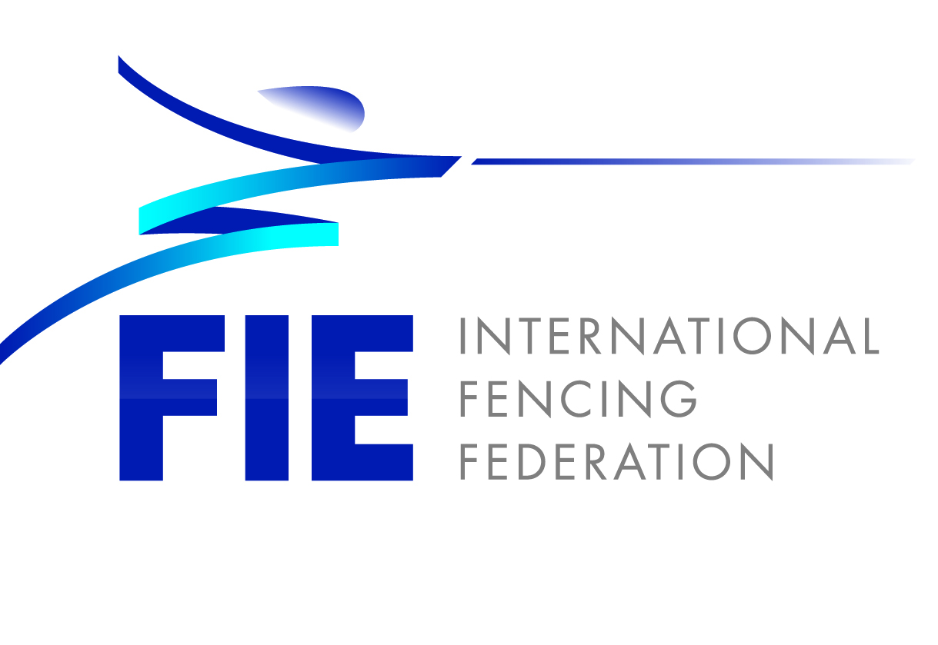

Donate your fencing gear!

Application document

Year 2024

- Introduction
- Application guidelines
- Specific rules
- Application form

- Introduction

Donate your fencing gear! is a project aiming at collecting from high-performance fencers their used equipment, safe and still in good conditions, to be donated to fencers living in disadvantaged realities and challenging environments.

It was approved by the FIE Executive Committee gathered in Nice on the 17th of February 2017.

The project rests on the FIE Statutes basic principles:
“In order for the fencing world to progress as a whole, solidarity between the strong and the weak is an undeniable requisite, whether it be between continents, federations or athletes.
This vision must become real. Our common singular motto: fencing together, universal fencing.”

The FIE regularly provides the National Federations members with brand-new equipment donation aiming at:
1) supporting the NFs to organise competitions
2) endowing high-performance athletes with appropriate equipment for FIE official competitions.

Beside the Help in Equipment program, the FIE has developed Donate your fencing gear! as a Sport-for-all and Sport-for-hope program, to broader the grassroots of fencing and bring the sport to underprivileged areas, where the cost of the equipment prevents people living in a challenging environment to be acquainted with the sport.

The used equipment collected through the donation of high-performance athletes and manufacturers will be distributed to the National Federations requesting it that meet the relevant criteria, and according to the rules mentioned in this document.

- Application guidelines

  - Who can apply
Are entitled to apply to receive used equipment collected by the FIE the National Federations, which present a charity project targeting disadvantaged areas and underprivileged people.
By “disadvantaged areas and underprivileged people”, it is meant:
- Suburbs of urban areas and rural areas lacking basic services, with particular regard to aggregation points and sporting facilities for the youth (among other slums, favelas, townships)
- Areas affected by natural disasters, such as flooding, earthquakes, famine, hurricanes, tornados
Situations not fitting in the above-mentioned description will be considered on a case-to-case basis.

  - How to apply
In order to apply, please fill in the enclosed application form.
  - Equipment allocation process

- The FIE HQ will screen the applications received.
- The projects matching all the criteria will be retained and included in the list of selected beneficiaries.
- The selected projects will be presented during the 2024 Junior and Cadet World Championships in Riyadh (KSA).
- The athletes will select the project they want to support with their donation.

- The selected National Federation representative(s) attending the 2024 World Championships in Riyadh will collect the equipment and bring it back to the respective country of origin (no shipment, direct distribution at the championships only).

- Specific rules
- Safety
a.1 It will be ensured that all donated fencing gears meet the safety requirements of the FIE. This safety check will be compulsory and only such fencing gear can be donated which is duly certified.
a.2 The safety check will be executed by a dedicated SEMI delegate appointed at the World Championships.

- Liability
Even if the donated fencing gears are checked by the FIE, an accident/injury can happen while using the donated fencing gear. The FIE will make sure that it will not be held liable for claims arising from such accidents/injuries. Therefore, the National Federations whose project has been selected undertake to conclude the following agreements:
  - Agreements between FIE (as donor) and the National Federations (“NFs” as recipients) with the following key topics:
      - FIE shall not be held liable towards the NFs and/or the final recipients for any injury caused resulting from the default of the donated fencing gear;
      - NFs shall, in their agreement to be concluded with the final recipients, ensure that the final recipients will not enforce any claim against FIE as donor in case of an injury resulting from the default of the donated fencing gear;
      - NFs shall indemnify FIE against any loss, claim, liabilities, obligations, demands, cause of action or proceedings arising in connection with an injury resulting from the default of the donated fencing gear.
These agreements shall be governed by Swiss law (law of the registered seat of the FIE).
  - Agreements between the NFs and the final recipients assuring that the final recipients will not enforce any claim against FIE as donor in case of an injury resulting from the default of the donated fencing gear.

4. Application form
CONTACT INFO
National Federation
Project Manager (name)
Phone no.
@
Dates of attendance in Riyadh 2024

MOTIVATION
Please describe the motivation of the project and the relation to fencing

GENERALITY
Please describe your project and how the donation will contribute to it, based on the following information:

- geographical area;
- category of people targeted;
- duration of the project;
- number of people affected;
- number of organised activities;
- other…

DETAILS
N. of people active in delivering the project and role of each member
Frequency of the activities (how many times per month, per week, per year…)
Places targeted (schools, hospitals, refugee camps…)
Existing support (Human resources, cooperation on a volunteer basis, financial support, media support, partnerships with other entities, other…)

SUPPORTING DOCUMENTATION

Please provide as an annex any document that you believe important such as certificates or awards, press articles, summary of reports, photographs or videos of activities.

Please send the present application form and the related supporting documents to:
elena.murdaca@fie.ch

Deadline: 31st January 2024

