Welcome To

**FIE SATELLIT TOURNAMENT WOMEN´S AND MEN´S FOIL 19 – 20 OCTOBER 2024**

**Manama - Bahrain**

I N V I T A T I O N

## Dear All Fencing Federations and Associations,

We are honored to invite you to participate in the 2024 FIE SATELLITE World Cup - Women´s and Men´s Foil which will take place on October 19th – 20th in Manama – kingdom of Bahrain.

Enclosed within this invitation are all the necessary administrative details, schedules, and annexes.

We sincerely look forward to your support and welcoming you to Manama, Kingdom of Bahrain.

Yours sincerely,

## Shaikh Ebrahim bin Salman Al Khalifa

President -

Bahrain Fencing Association

# Organizer:

**Bahrain Fencing Association** Building: 303 Road: 338 Block: 335 Umm Alhassam - Manama **Telephone:** +973 397 22 719

**E-Mail**: [bahrainfencing@gmail.com](mailto:bahrainfencing@gmail.com)

# Venue:

**Zain Basketball Arean – Umm Alhassam**

# Competition Schedule:

|  |  |  |
| --- | --- | --- |
| **Day & Date** | **Time** | **Program** |
| **Friday, October 18** | **16:00 to 21:00** | **Accreditation / Registration / Payments** |
| **Weapon control in the Hotel** |

|  |  |  |  |
| --- | --- | --- | --- |
| **Day & Date** | **Time** | **Program** | **Schedule of the day** |
| **Saturday, October 19** | **8: 00 - 9:30**  **10:00** | **Weapon control/ Registration / Payments**  **Start of Women's Individual Competition** |
| **16:00** | **Semi-final & Final** |  |

|  |  |  |  |
| --- | --- | --- | --- |
| **Day & Date** | **Time** | **Program** | **Schedule of the day** |
| **Sunday, 20**  **October 2024** | **8: 00 - 9:30**  **10:00** | **Weapon control/ Registration / Payments Start of Men's Individual Competition** |
| **16:00** | **Semi-final & Final** |  |

* These timetables are approximate will be confirmed once the registration is closed, which will be one week prior to the competition.

# Entry procedures

The fencers must have a license valid for the 2024-2025 season.

**Entry fee**: 50 $ – the entry fee can be paid at the registration desk in the hotel and Hall competition on Thursday 18th and Friday 19th at the sports venue (before the start of the competition).

**Entries of fencers and referees**: can only be made via the FIE website ([www.fie.org),](http://www.fie.org/) respecting the deadlines specified in the FIE.

# Referees

Participating countries must provide referees with FIE **A** or **B** licenses according to FIE rule (o. 25):

1 – 4 fencers - NO referee required 5 – 9 fencers - 1 referee

10 or more fencers - 2 referees

* The name(s) of the referee(s) must be notified via the FIE website.
* Should a national federation not provide the required number of referees, a fine according to FIE Organisation Rules (cf o.31, table of financial penalties and fines) will be inflicted on it.

Non-respect of quota is sanctioned by 1.000,00 € for every missing referee per competition and shall be paid by the Fencers National Federation to the Organiser at the same time as the information is sent to the Organiser (according to FIE Rule o.31.)

# Accreditations:

Officials and athletes should provide a passport-sized photo for ID card sent to Email: [brnfencing@gmail.com](mailto:brnfencing@gmail.com) by 20 September 2024.

For each athlete, coach, and member of the delegation, a photo should be sent as “jpg” and the format file name of the photo: <country>_<official/athlete/Coach> _<name>. For example BRN_ ATHLETE_ ALI _MOHAMED.jpg

# Entry visa:

Please kindly share the passport copy via email [bahrainfencing@gmail.com](mailto:bahrainfencing@gmail.com) to obtain an entry visa latest by 1st October 2024.

If you need more information about the visa support letter, don't hesitate to get in touch with bahrainfencing@gmail.com

# Transportation:

Transfer airport – hotel for arrivals and departures hotel – airport is **25 $** per person. The arriving and departure forms must be sent to the following email: [brnfencing@gmail.com](mailto:brnfencing@gmail.com)

# Accommodation:

**Official Hotels:**

|  |  |  |  |
| --- | --- | --- | --- |
| HOTEL: **RAMADA RESORT BY WYNDHAM** | | | |
| SGL Room | DBL Room | TRIPLE Room | Half board (breakfast + dinner) Transportation from/ to sports venue |
| US $ 130 | US $ 180 | US $ 250 |

* **All rates included all taxes, breakfast, dinner, free wifi**
* **Free transfer (Hotel – Sports Venue – Hotel) can be used by guests only in official hotels.**

**Important Information:**

**Check-in time in the hotel is 14:00 pm. The period between 08:00 am to 14:00 pm will be charged in size of 50% of the room rate accordingly. If the check-in time in the hotel till 08:00 am, will be charged in size of 100% of the room rate.**

**Check-out time in the Hotel is 12:00 a.m. Check-out time for period from 12:00 am to 18:00 pm will be charged in size of 50% of the room rate accordantly. Check-out time after 18:00 am will be charged in size of 100% of the room rate.**

## Participating Federations/Associations can send the payment via bank transfer and MUST share the payment advice to

**WhatsApp: 00973 33940430 or email** [**brnfening@gmail.com**](mailto:brnfening@gmail.com)

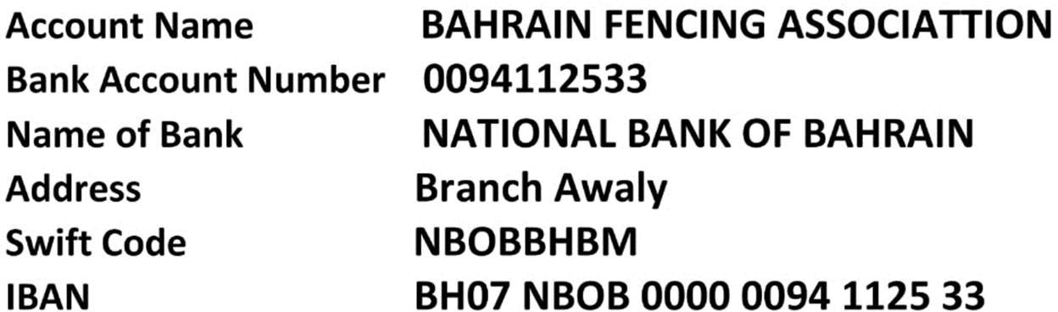

***Welcome To Manama, Kingdom of Bahrain***

PRELIMINARY ENTRY FORM (FORM **1**)

Please send the filled form to [brnfencing@gmail.com](mailto:brnfencing@gmail.com)

### Entry By Numbers

Federation:

Address:

Email:

Telephone: Fax :

**Number of Team Officials/Coaches/Referees:**

|  |  |
| --- | --- |
| Members | Number |
| Officials |  |
| Coaches |  |
| Total |  |

**Number of Fencers For Each Event:**

|  |  |  |
| --- | --- | --- |
| No. | Foil Event | |
| Fencers | |
| Men’s Foil |  |  |
| Women’s Foil |  |  |
| Total |  |  |

Name / Designation Date Signature/ Stamp

# TRANSFER FORM

Please send the filled form to [brnfencing@gmail.com](mailto:brnfencing@gmail.com)

### Entry By Name: Transfers

Federation:

Address:

Email:

Telephone: Fax :

|  |  |  |  |  |  |
| --- | --- | --- | --- | --- | --- |
| No. | Full Name | Date of  Arrival | Flight Information | Date of departure | Flight information |
|  |  |  |  |  |  |
|  |  |  |  |  |  |
|  |  |  |  |  |  |
|  |  |  |  |  |  |
|  |  |  |  |  |  |
|  |  |  |  |  |  |
|  |  |  |  |  |  |
|  |  |  |  |  |  |
|  |  |  |  |  |  |
|  |  |  |  |  |  |
|  |  |  |  |  |  |
|  |  |  |  |  |  |
|  |  |  |  |  |  |
|  |  |  |  |  |  |
|  |  |  |  |  |  |
|  |  |  |  |  |  |
|  |  |  |  |  |  |
|  |  |  |  |  |  |
|  |  |  |  |  |  |
|  |  |  |  |  |  |
|  |  |  |  |  |  |
|  |  |  |  |  |  |
|  |  |  |  |  |  |
|  |  |  |  |  |  |

Name / Designation Date Signature/ Stamp

Please send the filled form to [brnfencing@gmail.com](mailto:brnfencing@gmail.com)

### ACCOMMODATION FORM

Federation:

Email:

Telephone: Fax :

**Names of Officials:**

|  |  |  |  |  |  |
| --- | --- | --- | --- | --- | --- |
| No. | Full name  (in Capital Letters) | Check in day | Check out day | Category of the  rooms | No. of nights |
|  |  |  |  |  |  |
|  |  |  |  |  |  |
|  |  |  |  |  |  |
|  |  |  |  |  |  |
|  |  |  |  |  |  |
|  |  |  |  |  |  |
|  |  |  |  |  |  |
|  |  |  |  |  |  |
|  |  |  |  |  |  |
|  |  |  |  |  |  |
|  |  |  |  |  |  |
|  |  |  |  |  |  |
|  |  |  |  |  |  |
|  |  |  |  |  |  |
|  |  |  |  |  |  |
|  |  |  |  |  |  |
|  |  |  |  |  |  |
|  |  |  |  |  |  |

Name / Designation Date Signature/ Stamp

**This form must be submitted by 28th September 2024**