
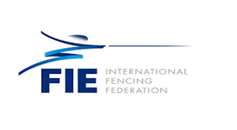
UZBEKISTAN SATELLITE 2026: FIE WOMEN’S FOIL

12th September 2026
Dear Fencing Friends,
It is with great pleasure that I invite you to the Uzbekistan SATELLITE 2026: FIE Women’s Foil on behalf of the Uzbekistan Fencing Federation, which will take place on 12th September 2026 in Tashkent, Uzbekistan.
Detail of the competition as follows:
ORGANIZERS:

Host Federation: Uzbekistan
Full Name of the National Federation: Uzbekistan Fencing Federation
Address: 100027 Tashkent, 98A, Islam Karimov str
Telephone Number: 998711477171
Email: uzb.fencing@gmail.com

COMPETITION VENUE:

Competition Venue Fencing Hall Pakhtakor,
Location:. Islam Karimov 98A , Tashkent

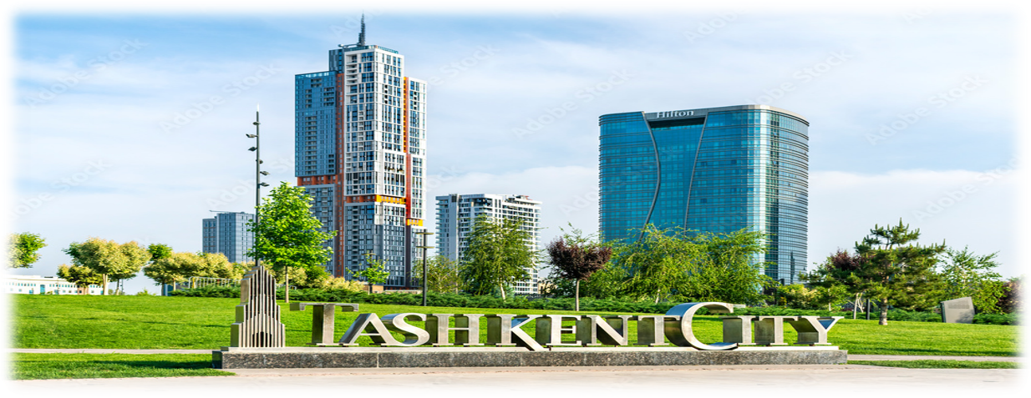

SCHEDULE OF THE COMPETITION:

Detailed day by day schedule
Date | Time | Events | Remark
FRIDAY  11th September 2026 | 10:00 – 18:00 | Weapon control | Venue
FRIDAY  11th September 2026 | 10:00 – 17:00 | Registration / Accreditation  Payment of Entry Fee and Accommodation | Venue
INDIVIDUAL COMPETITION |  |  | Venue
SATURDAY  12th September 2026 | 08:30 | Weapon Control | Venue
SATURDAY  12th September 2026 | 9:00 – 9:30 | Reporting time | Venue
SATURDAY  12th September 2026 | 10:00 | Beginning of round of pools | Venue
SATURDAY  12th September 2026 | 14:00 | Semi-finals – Final | Venue
SATURDAY  12th September 2026 | 16:00 | Prize presentation | Venue
Depending on the number of participants, the timing is approximate and subject to change.

PARTICIPATION:

Participation is not limited.

ENTRIES:

Open to all fencers with a valid 2026 – 2027 FIE License.
No fence

can only be made at the FIE website, www.fie.org,
respecting the deadlines specified in the FIE Rules (cf. o.54).

ENTRY FEES:

Individual competition: EUR 80
The entry fee can be paid at registration BEFORE the start of the competition.

REFEREE OBLIGATION:

Participating countries must be accompanied by referee with FIE A or B licenses as below (cf.
o.25). Delegations not respecting the quota must pay A FINE OF EUR 1,000 PER REFEREE.

1 – 4 fencers | No referee required
5 – 9 fencers | 1 referee
10 or more | 2 referees

FORMULA:
Satellite competitions will be organized according to FIE rules.
Live results will be posted on www.fencingtimelive.com
DOPING CONTROL:

According to FIE regulations and rules

VISA SUPPORT:

The Organizing National Federation declares that its national authorities guarantee the granting of visas to all the participants of the member federations of the FIE.

To avoid delays, all delegations are required to submit their visa requests in time
Participants who require a visa are kindly requested to begin the application process as early as possible.

To facilitate visa issuance, the Organizing Committee will provide official invitation letters upon request.

Please send the personal data of the participants that you wish to include in the
invitation letter to uzb.fencing@gmail.com

The personal data should be sent in an editable format (Word, Excel, Text)

• Full name (as in passport)
• Nationality
• Date and place of birth
• Passport number
• Passport issue and expiry dates
• Role at the event (athlete, coach, referee, official, staff, etc.)
• Dates of arrival and departure
• Copy of the passport (photo page)

For any questions related to visas or entry requirements, please contact:
• uzb.fencing@gmail.com
• Federations requiring visa support should send passport copies and travel details to: uzb.fencing@gmail.com

ACCOMMODATION AND TRANSPORT:
Official hotels, transport, and special rates:
Accommodation name | Address | Rate
The Elements Hotel | 13 Khushnavo Street, Yunusabad District, Tashkent, Uzbekistan | SGL Room  120 USD
The Elements Hotel |  | DBL Room  140 USD
Room prices include buffet breakfast, taxes, free
WIFI Internet

• Accommodation email: uzfencing@gmail.com
• Deadline: 2026.08.15.
• Transportation information: The organizer will provide free transportation for competing delegations staying in the official hotels during the competitions. This transport will work to and from the official hotel, accreditations, training and competition Transfer for arrivals and departures is available from official hotels only. Transfers Airport – Hotel – Airport -30$ per person If you need airport pick-up service, please send your flight information to the organizing committee
• Transport email: uzfencing@gmail.com
• Airport: Islam Karimov Tashkent International Airport (TAS)

CONTACT INFORMATION:

Organizing Committee:
• Name: Uzbekistan Fencing Federation
• Address: 100027 Tashkent, 98A, Islam Karimov str
• Email: uzb.fencing@gmail.com
• Telephone: 998711477171

Best regards,

Makhsud Abdusamadov

President

Fencing Federation of Uzbekistan

